AWS:Launch AWS EC2 Instance
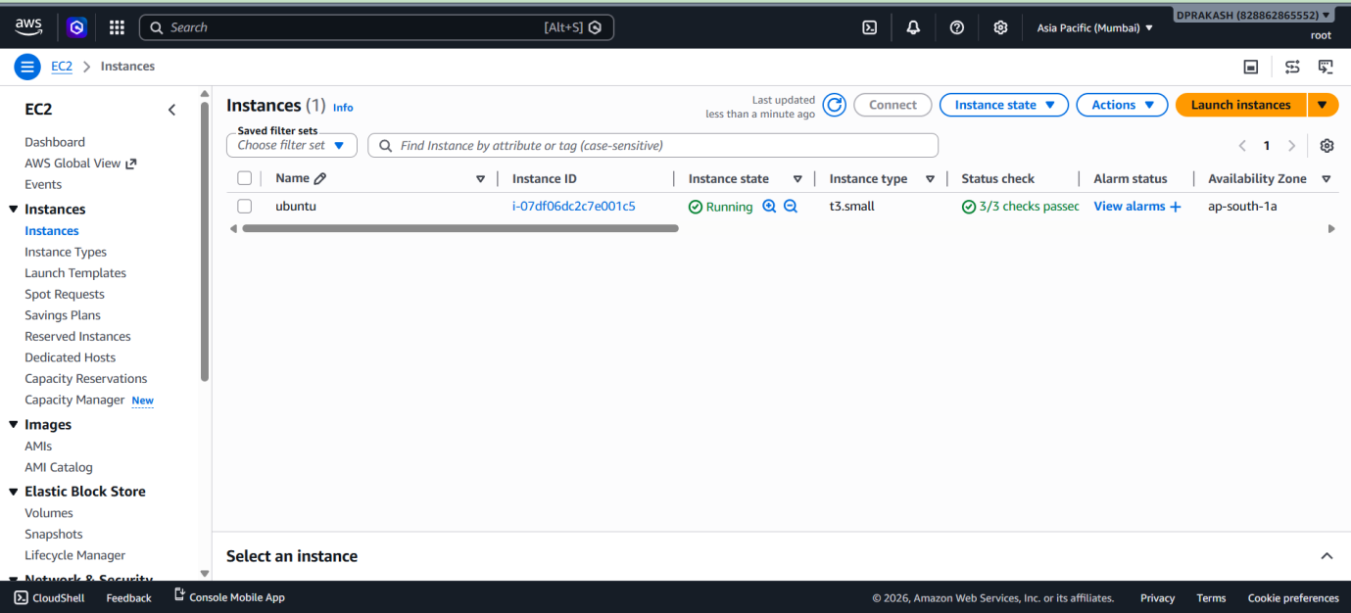

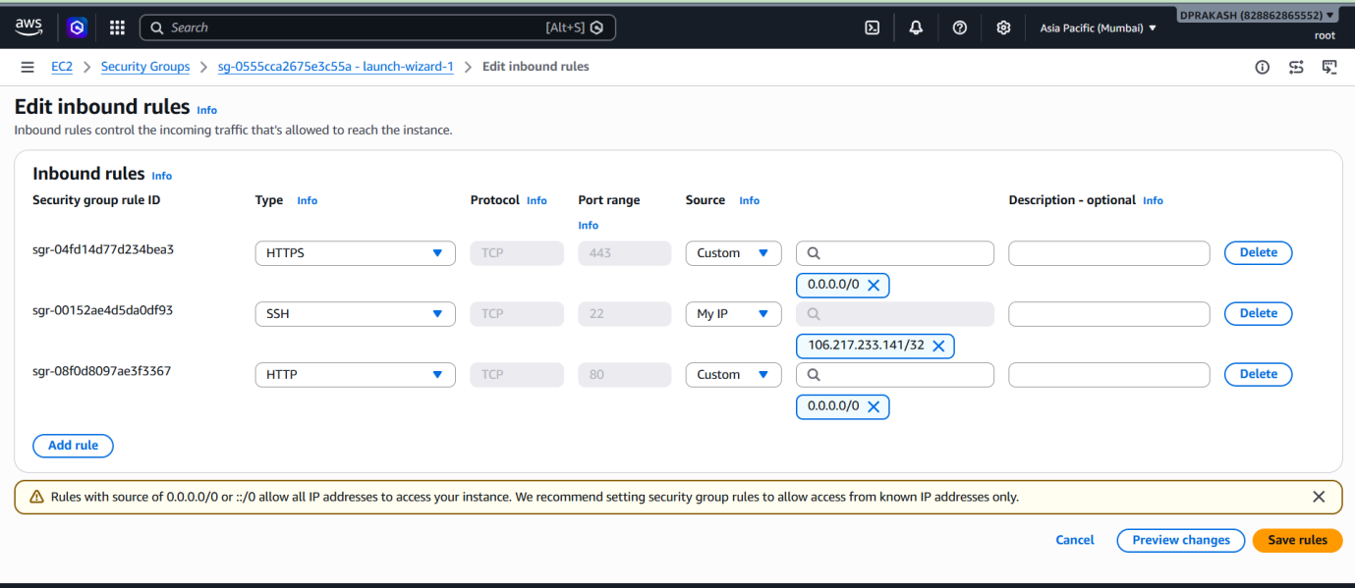

Clone Application From Git Repository:
git clone https://github.com/sriram-R-krishnan/devops-build.git

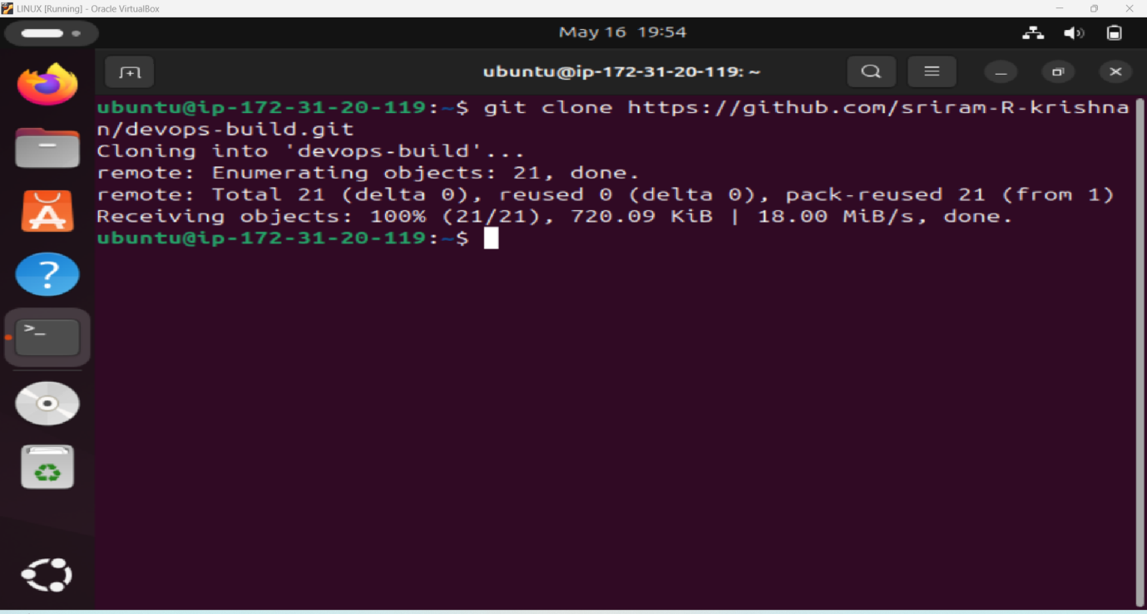

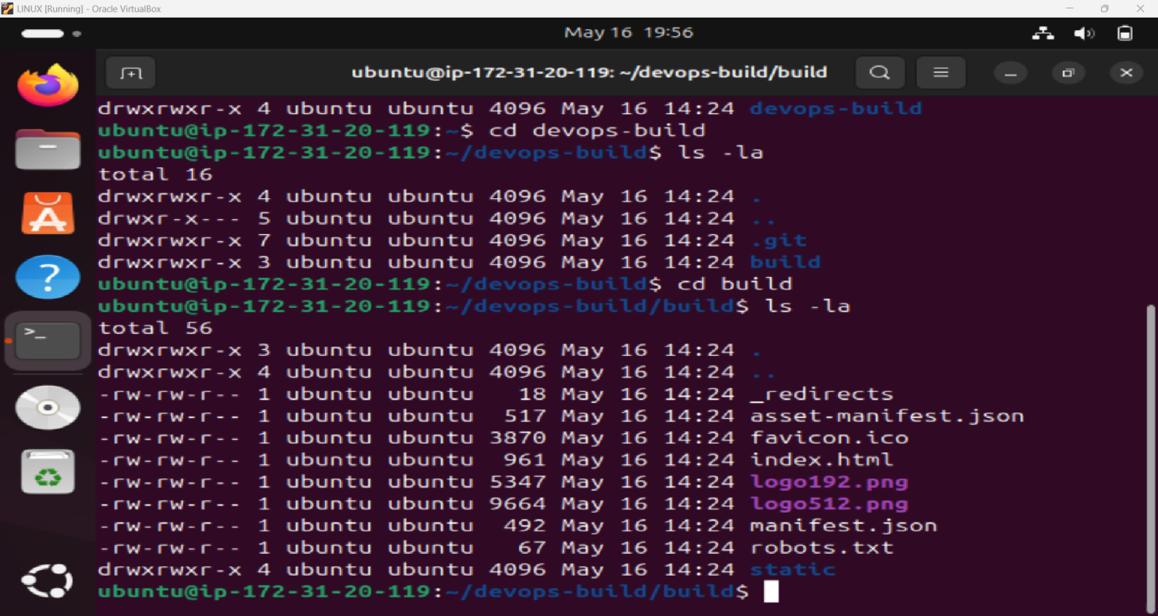
sudo apt update
sudo apt install docker.io –y
sudo systemctl start docker
sudo systemctl enable docker
docker --version

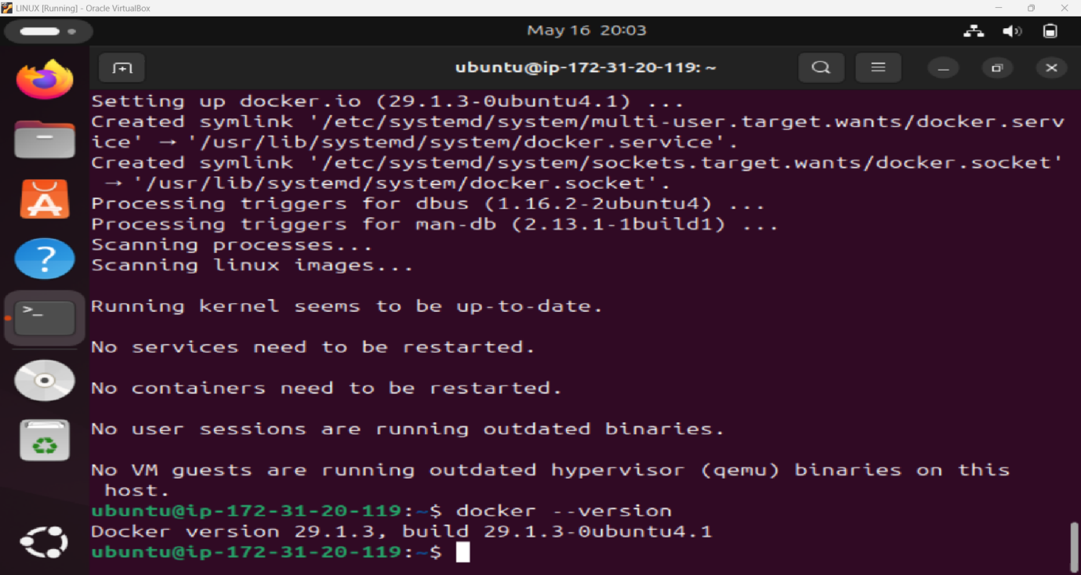

sudo apt install docker-compose –y
vi Dockerfile
vi docker-compose.yml
docker build -t react-app .
docker run -d -p 80:80 react-app
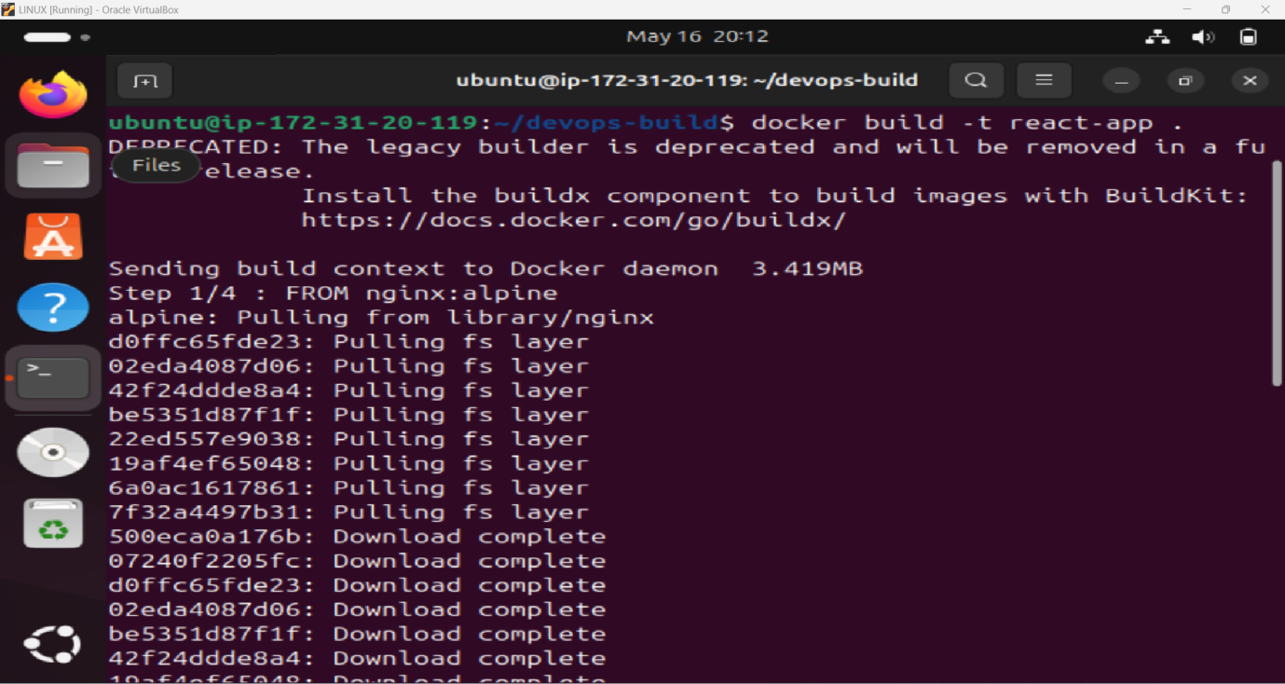

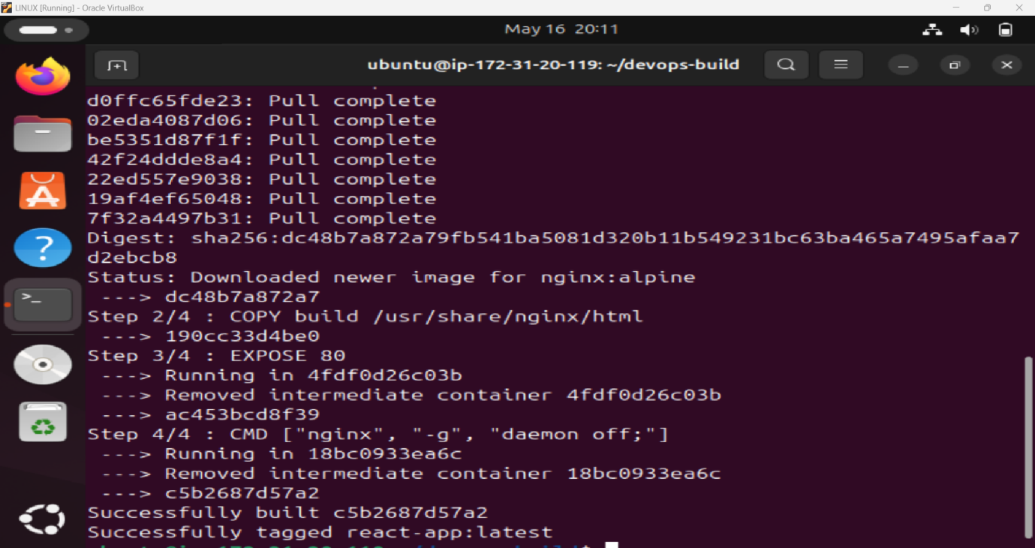

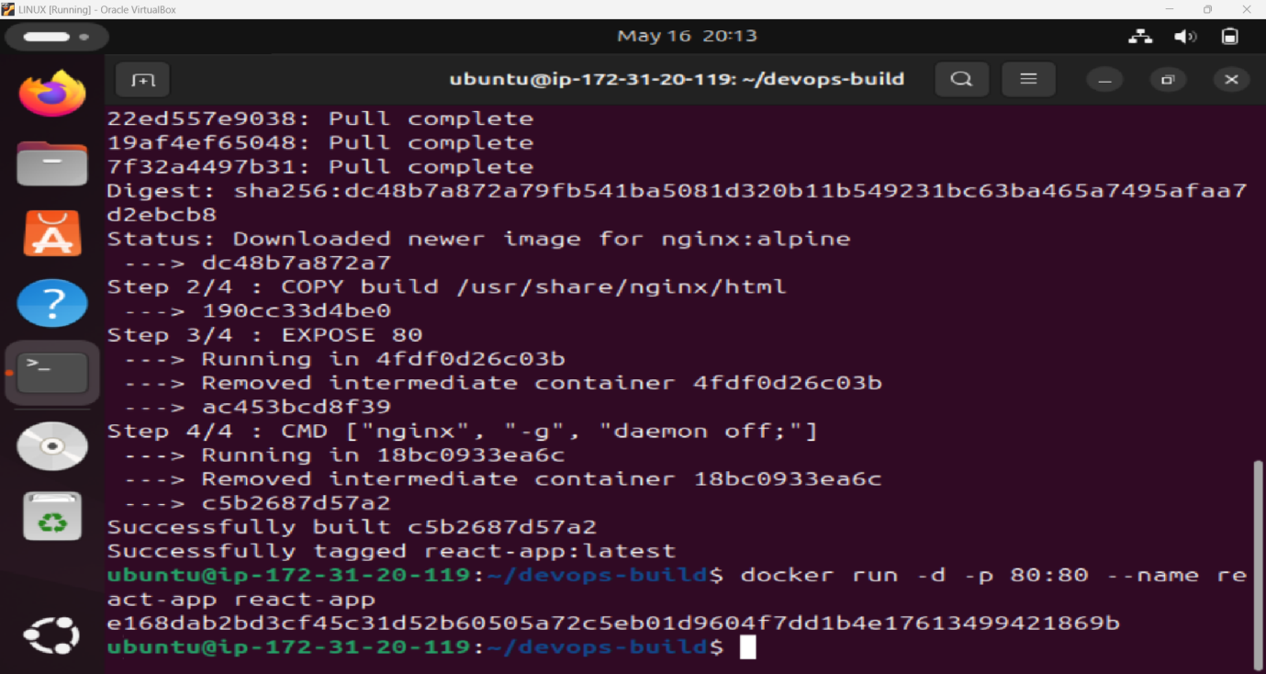

docker ps
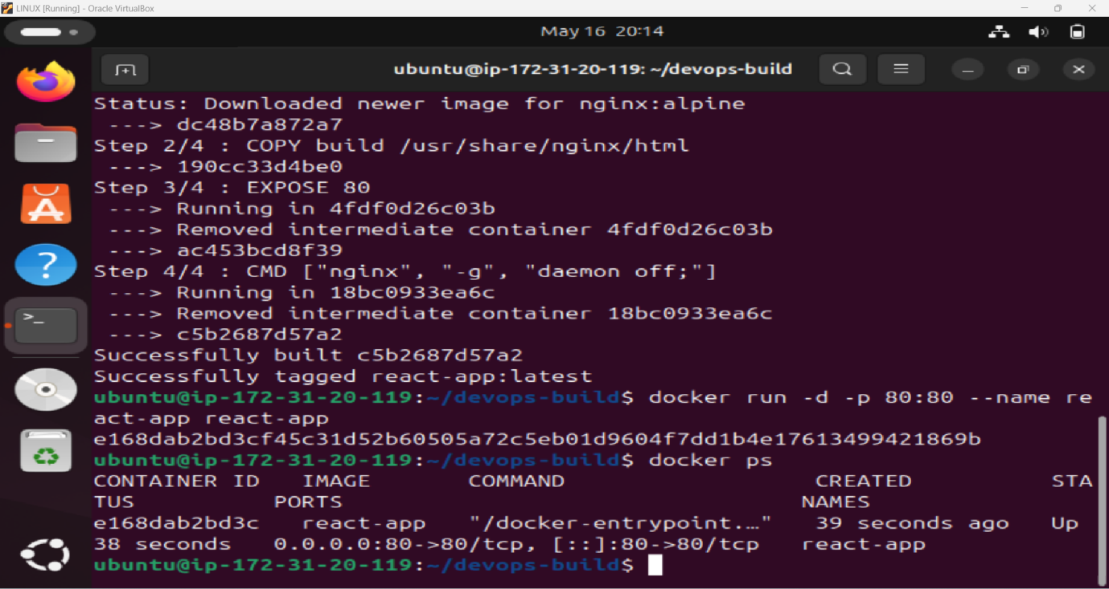

Now Open Public IP Address in Web Browser

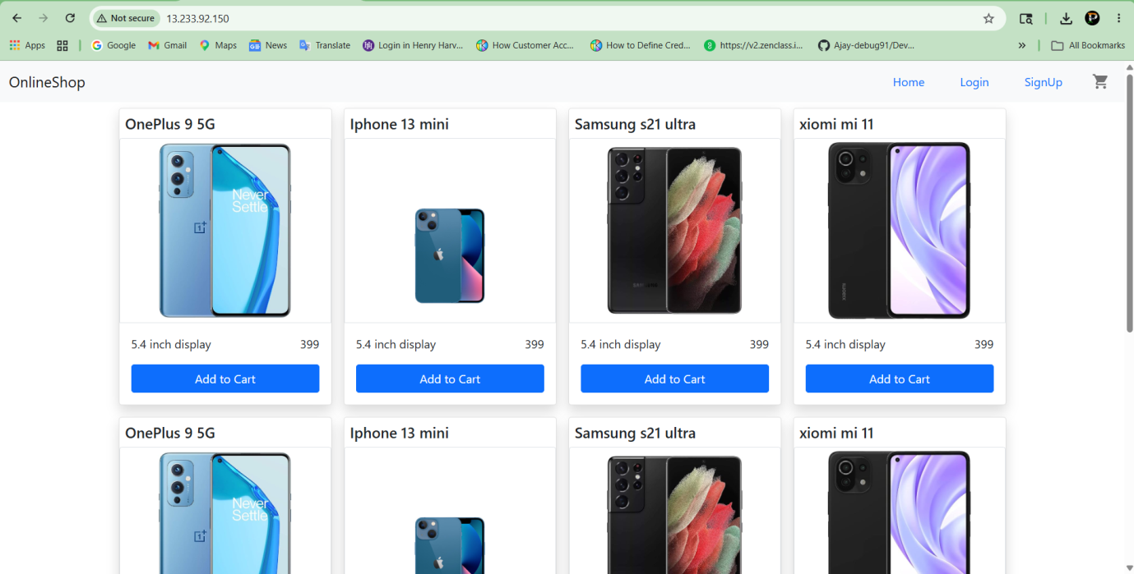

Create build.sh And deploy.sh Files

vi build.sh
nano build.sh
./build.sh
vi deploy.sh
chmod +x deploy.sh
./deploy.sh
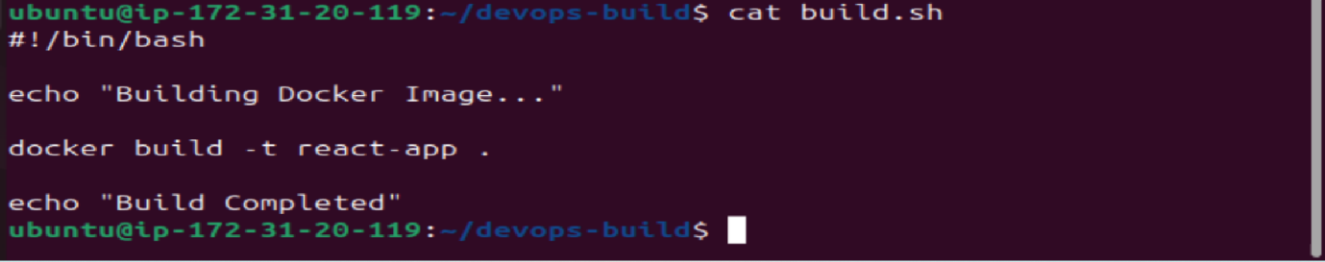

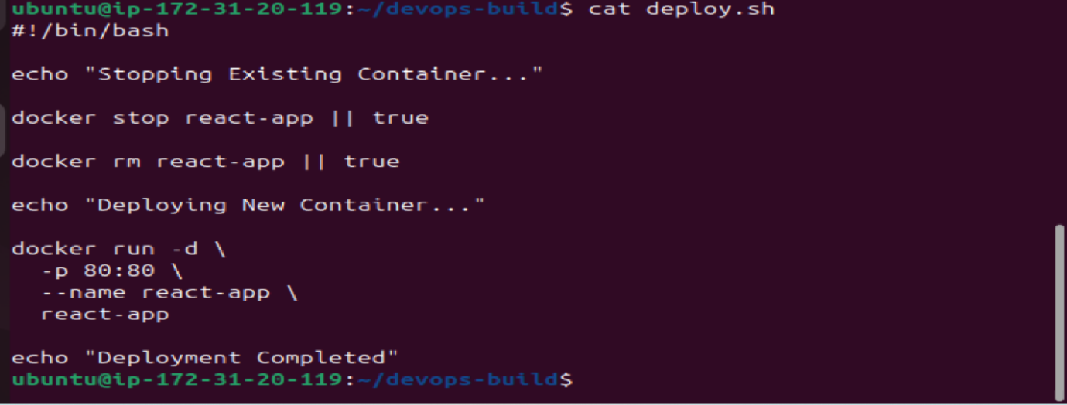

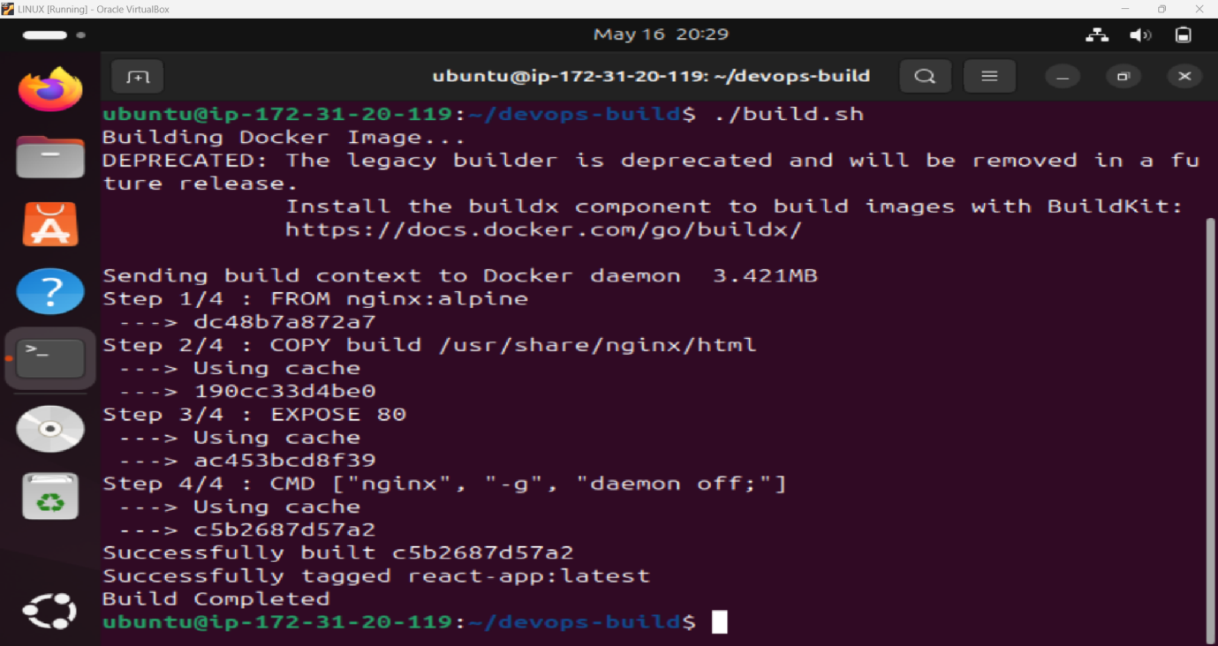

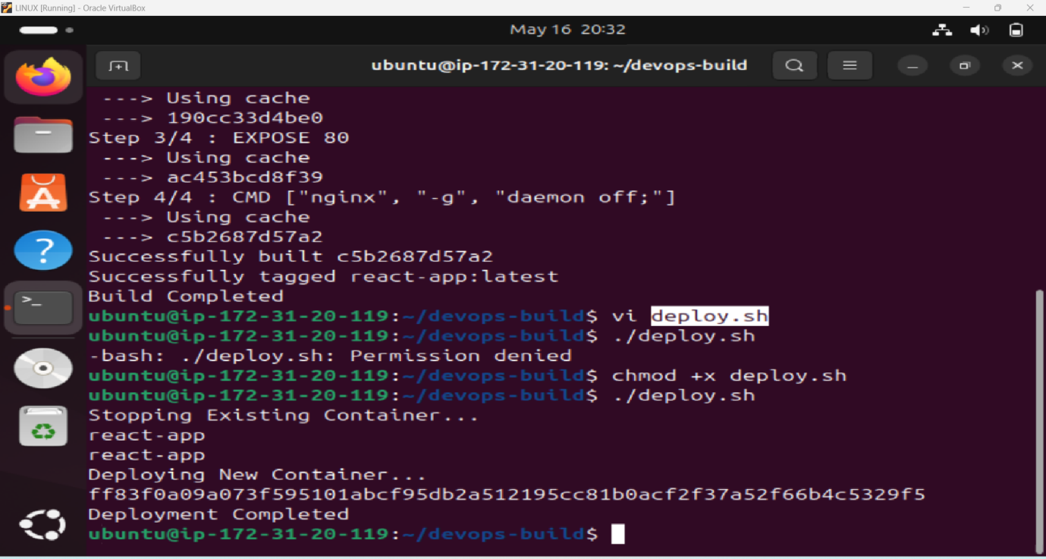

Push Code Using CLI To Git:
git init
git checkout -b dev
git remote add origin https://github.com/PrakashD189/Devops_E-Commerce-App.git
git add .
git push -u origin dev
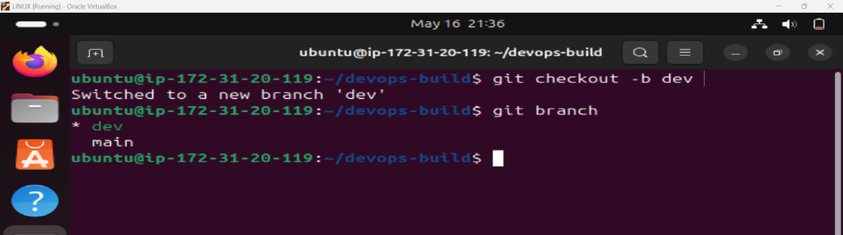

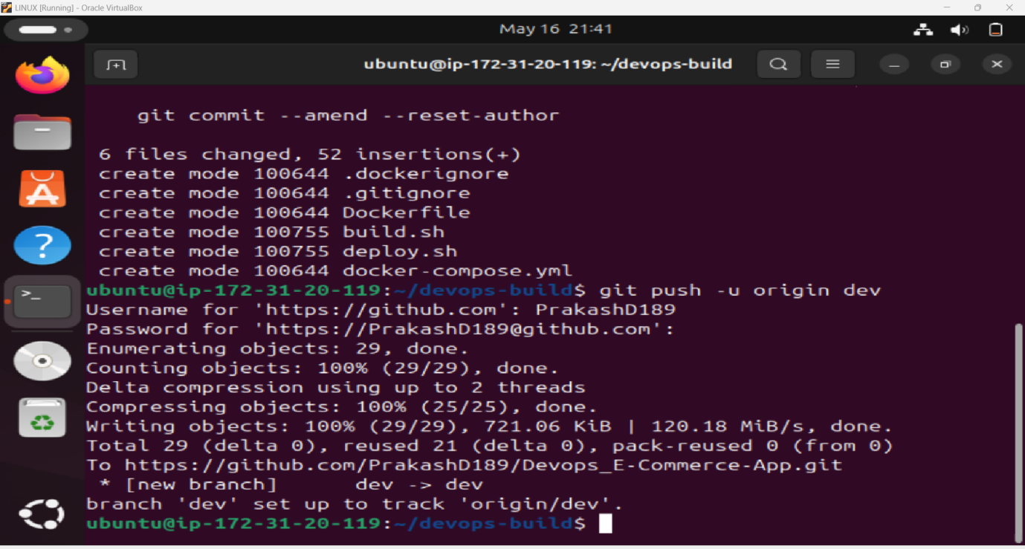

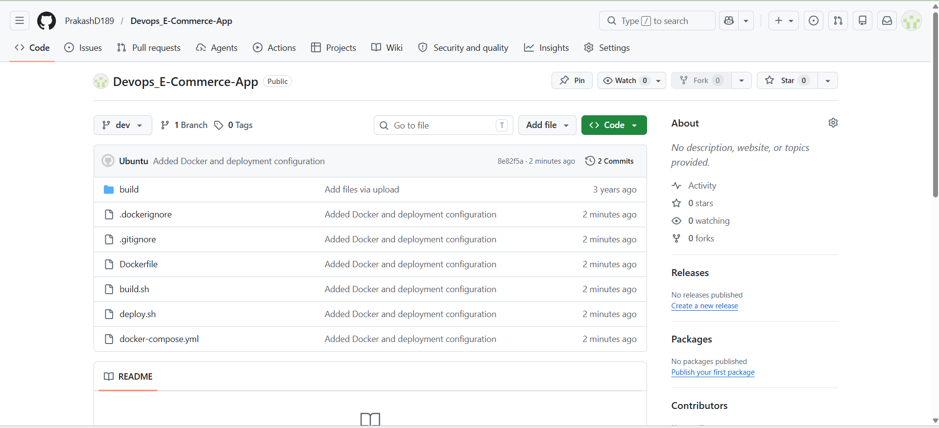

Docker Login And Push Images
docker login
docker tag react-app dprakash4a3/dev:latest
docker push dprakash4a3/dev:latest
docker tag react-app dprakash4a3/prod:latest
docker push dprakash4a3/prod:latest
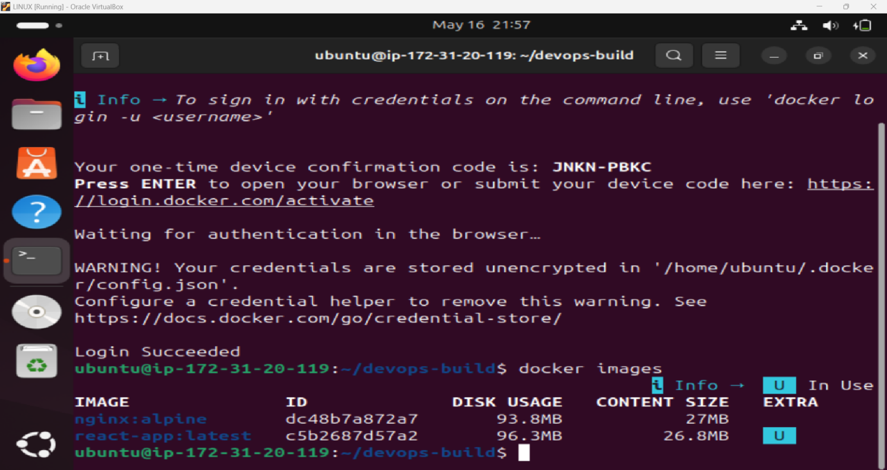

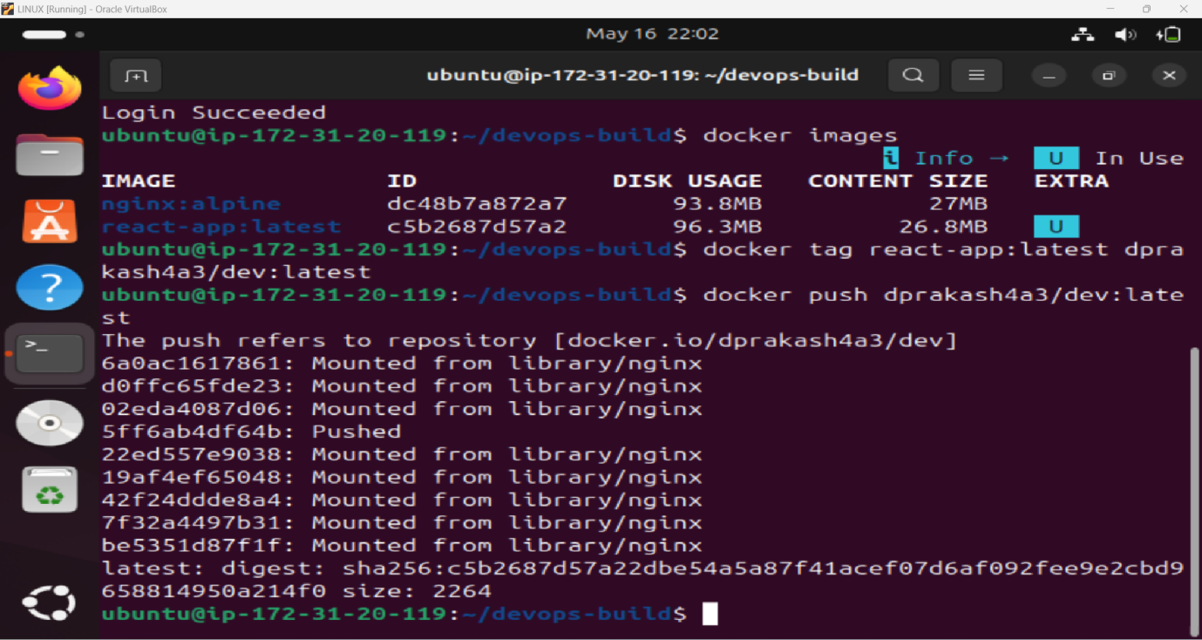

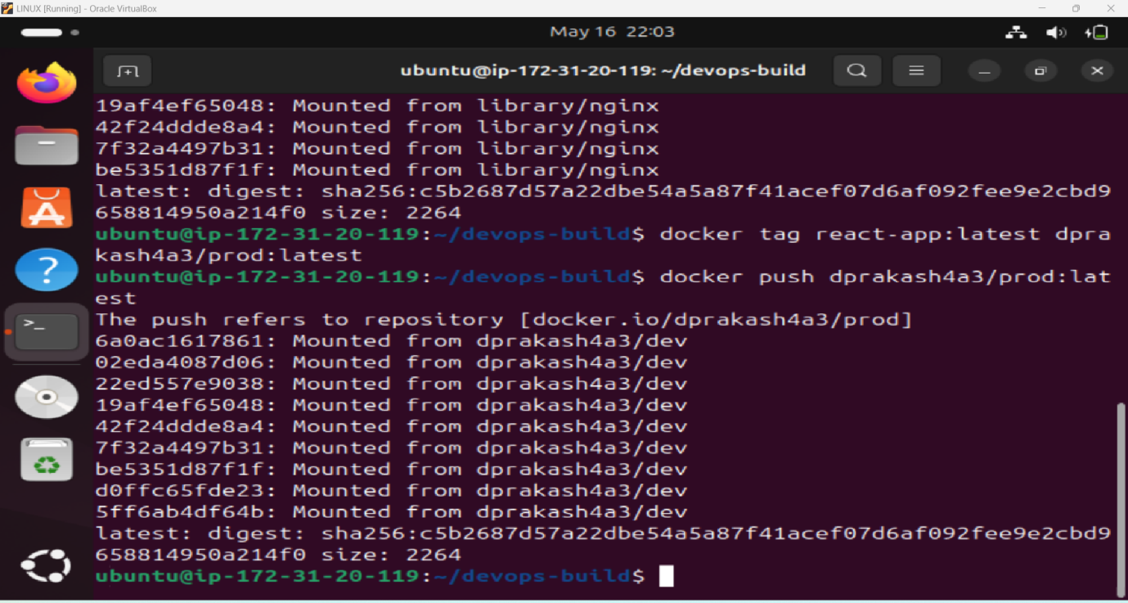

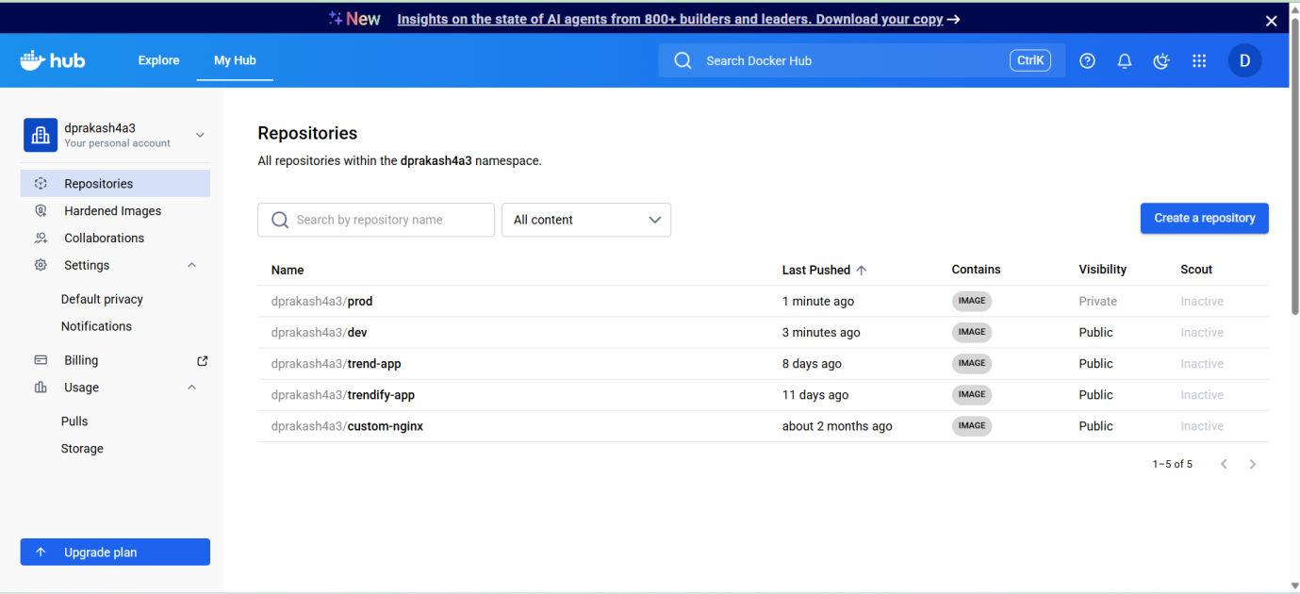

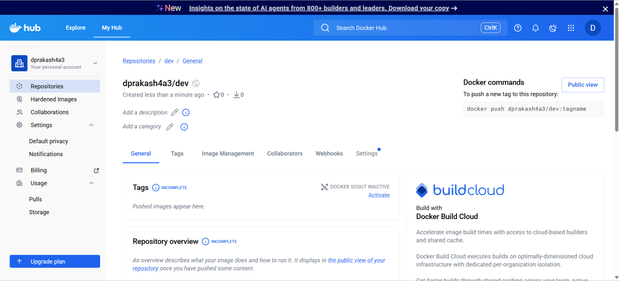

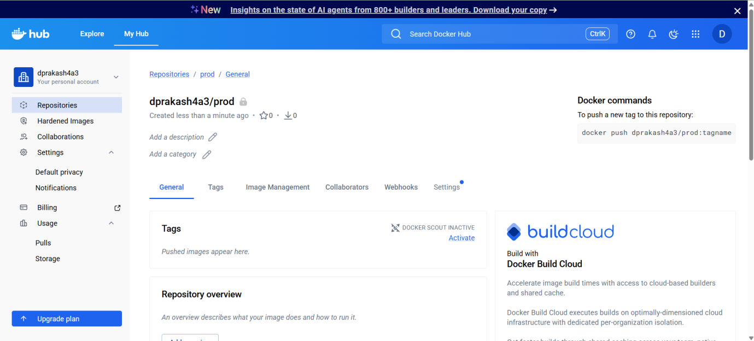

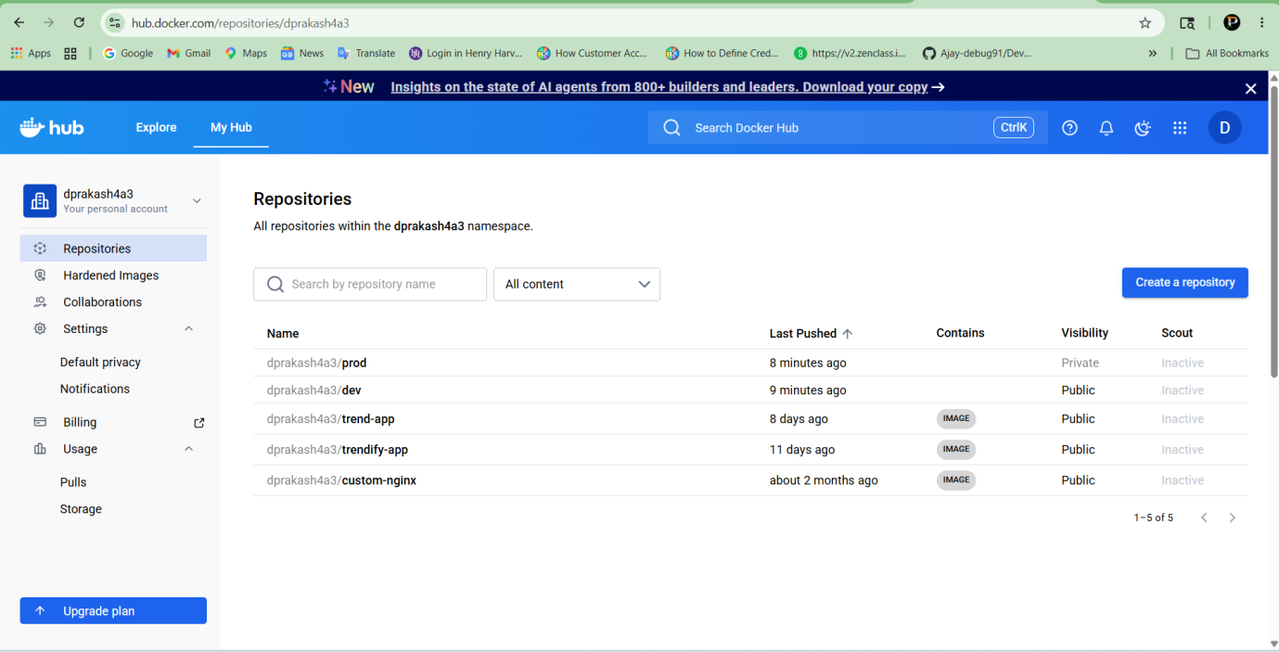

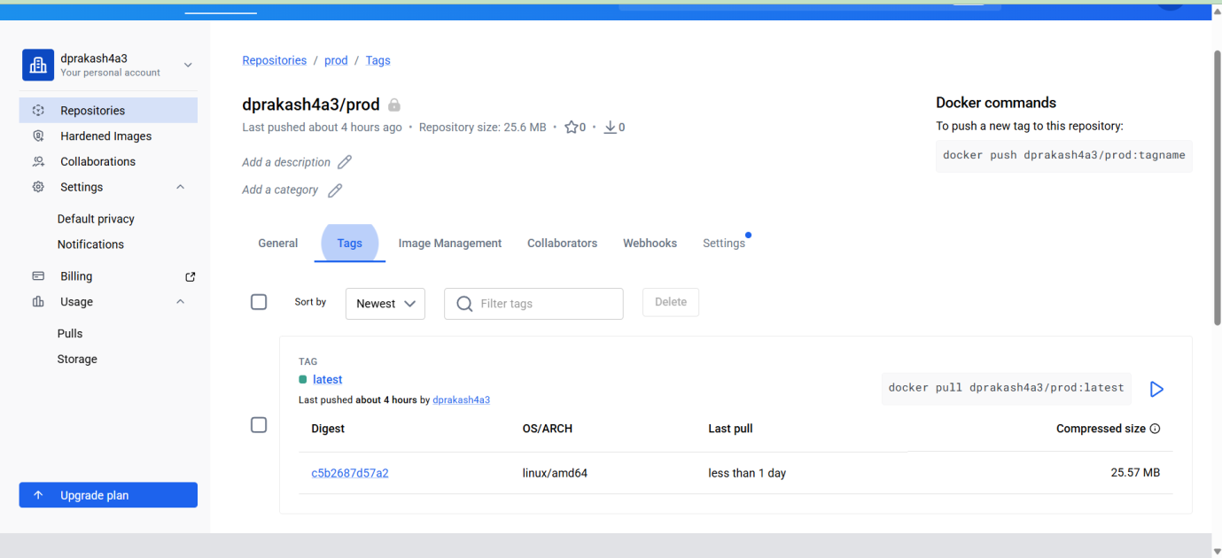

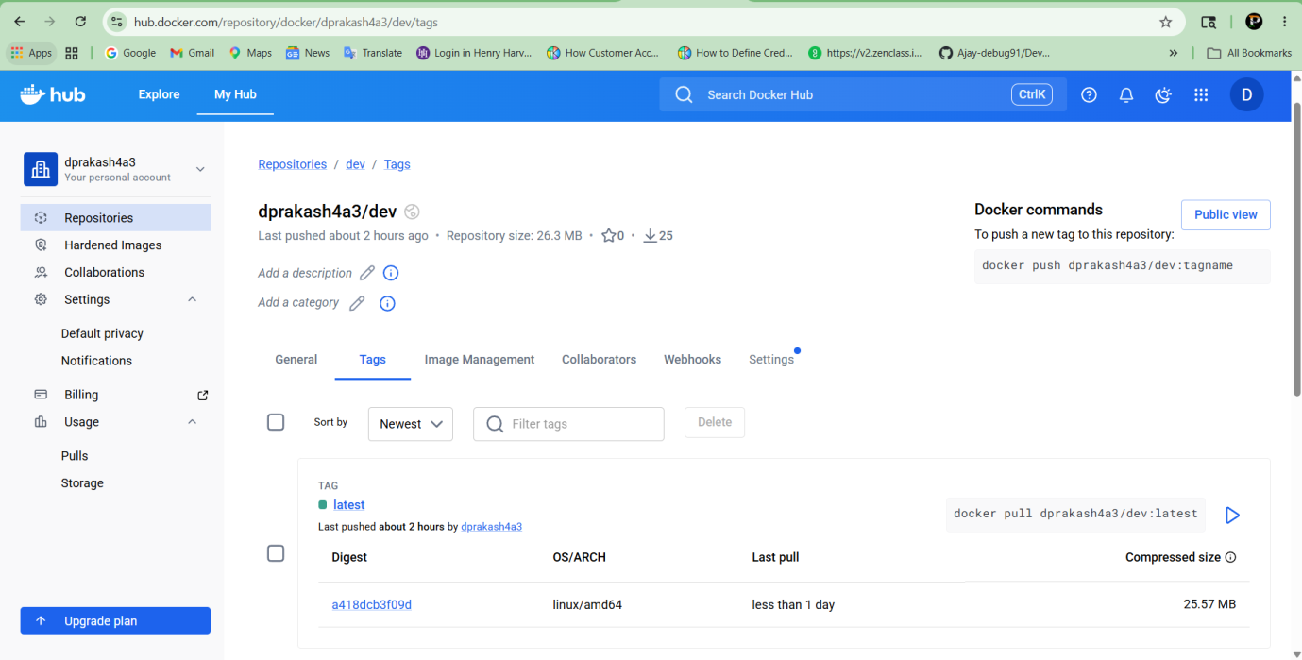

Install Jenkins:
sudo apt update
sudo apt install fontconfig openjdk-21-jre
java –version

sudo wget -O /etc/apt/keyrings/jenkins-keyring.asc \
https://pkg.jenkins.io/debian-stable/jenkins.io-2026.key
echo "deb [signed-by=/etc/apt/keyrings/jenkins-keyring.asc]" \
https://pkg.jenkins.io/debian-stable binary/ | sudo tee \
/etc/apt/sources.list.d/jenkins.list > /dev/null
sudo apt update
sudo apt install Jenkins
sudo usermod -aG docker jenkins

Create Jenkinsfile:
vi Jenkinsfile
sudo systemctl restart Jenkins
sudo systemctl enable Jenkins
sudo systemctl status jenkins
Open Jenkins:
Open The Browser And Check The Public IP Adress in Port 8080
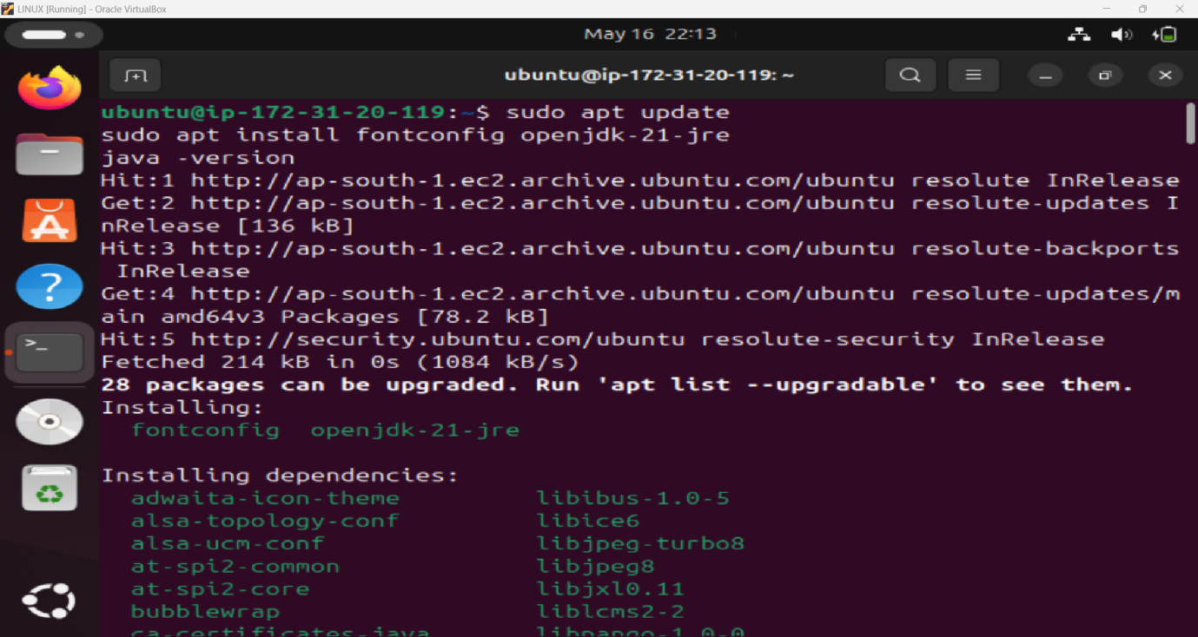

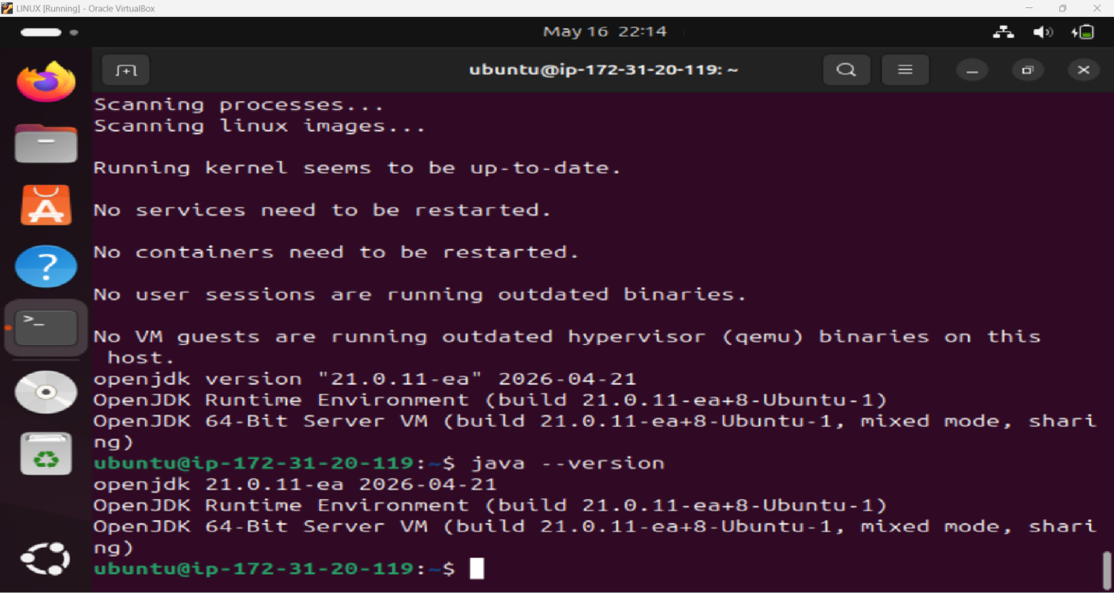

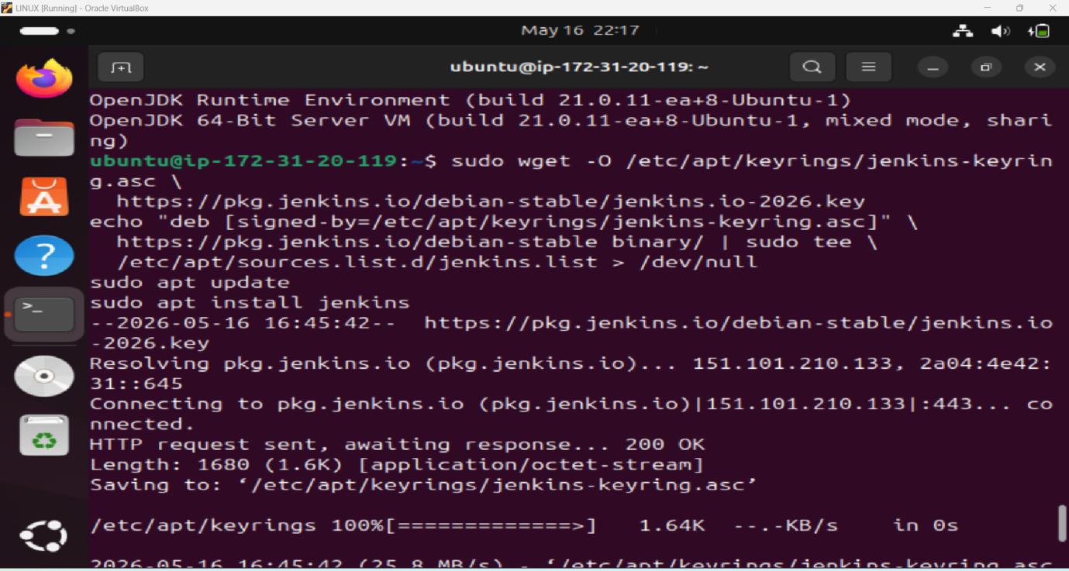

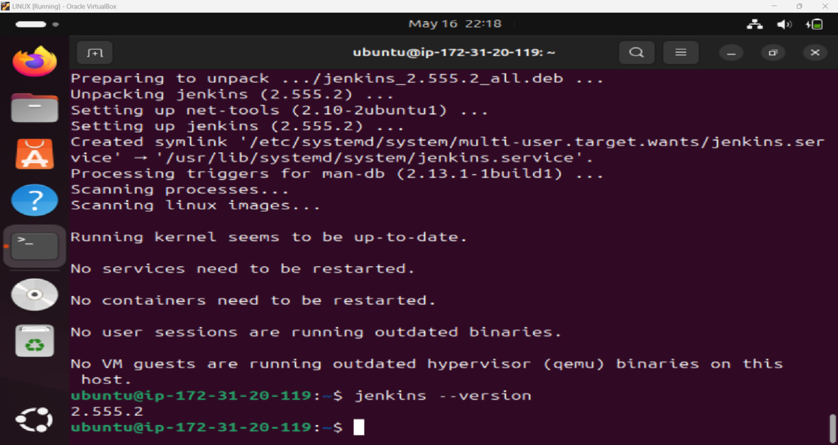

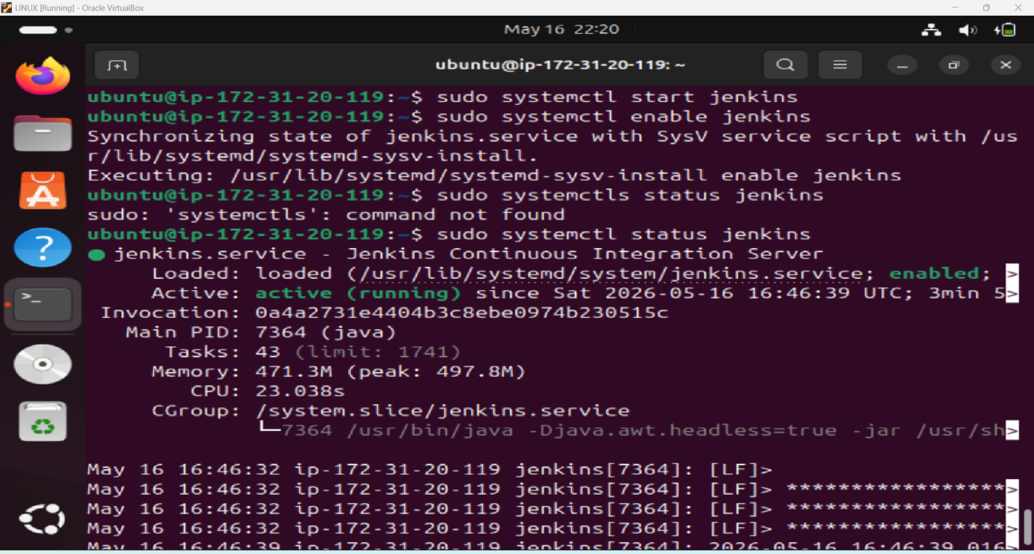

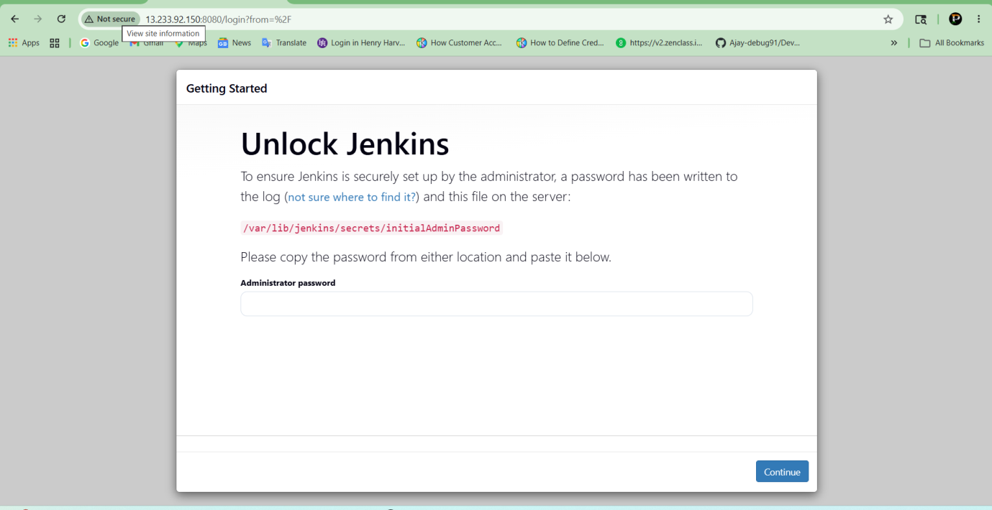

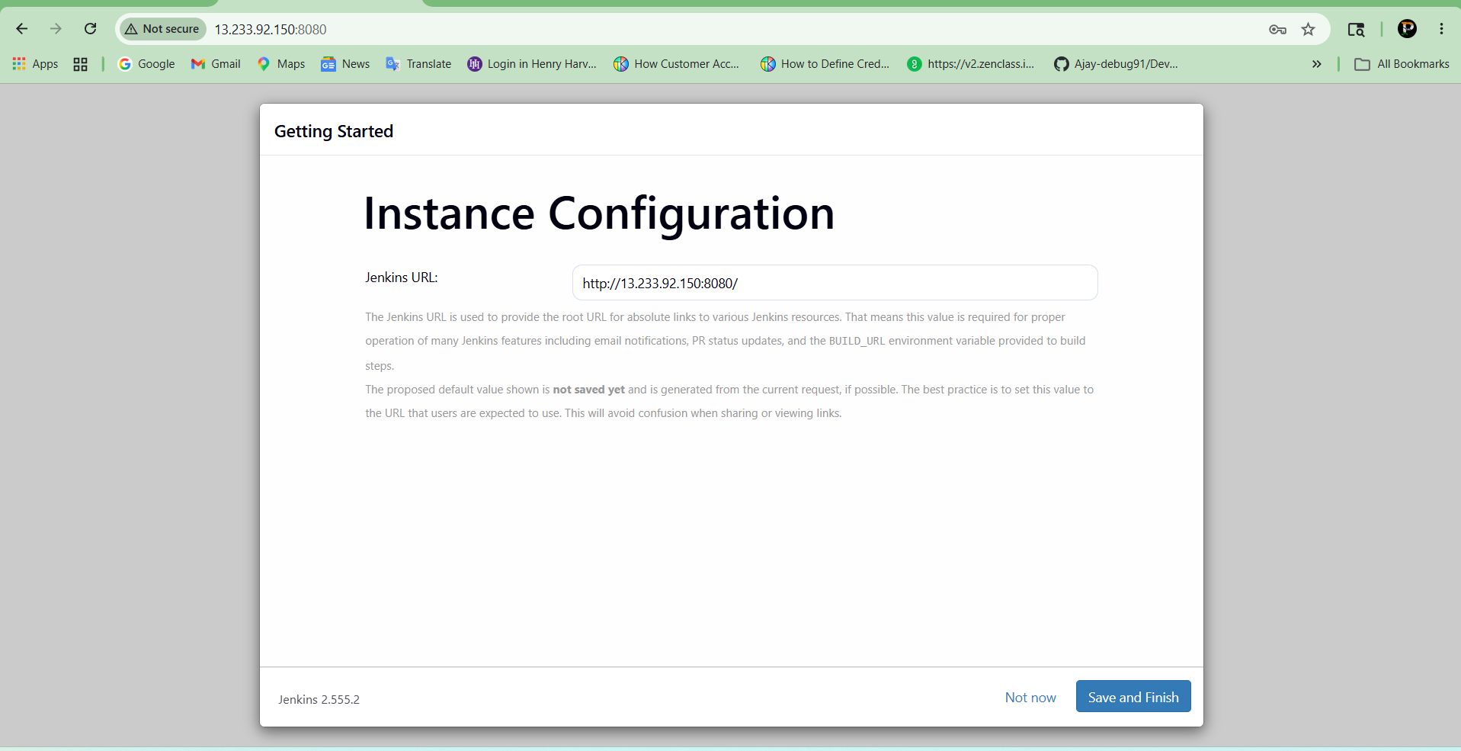

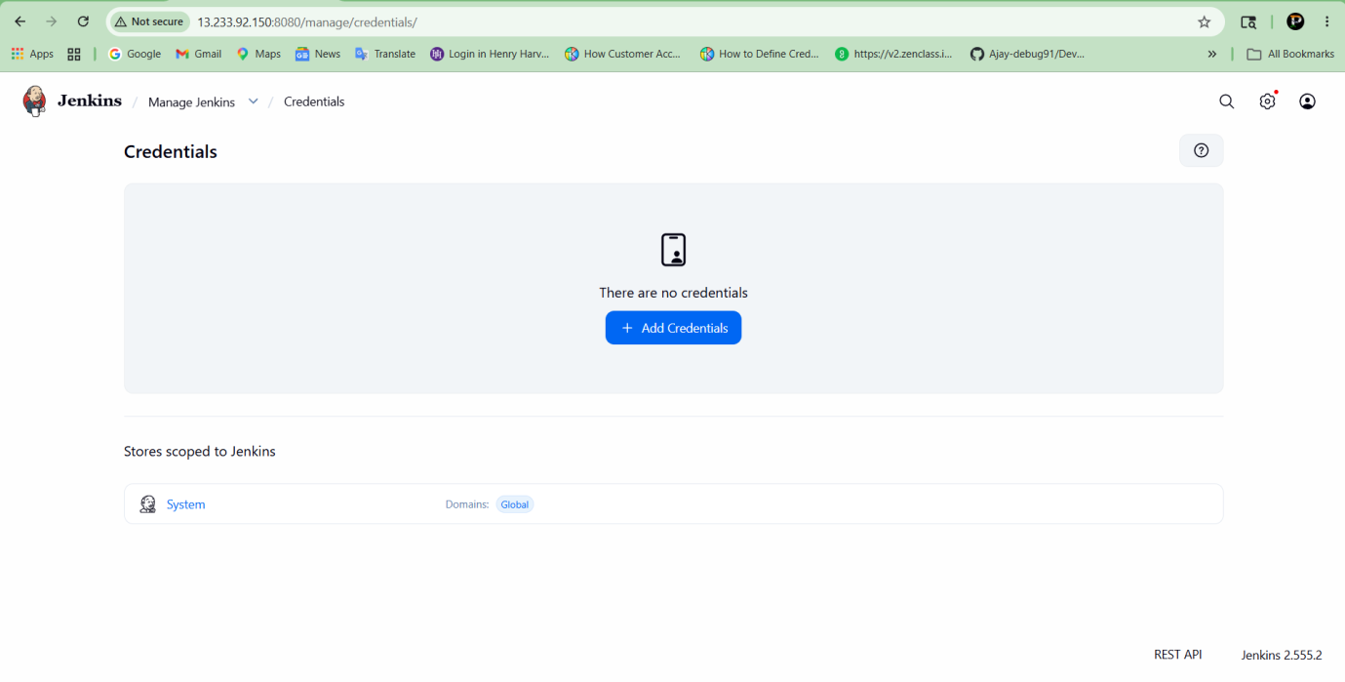

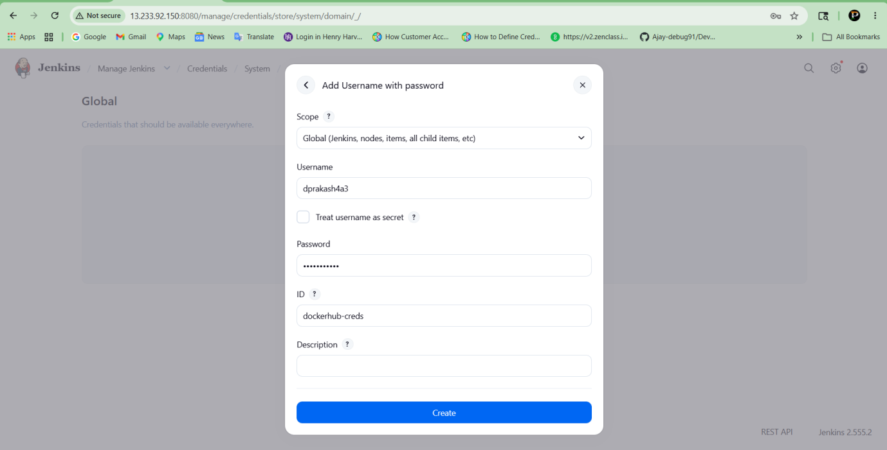

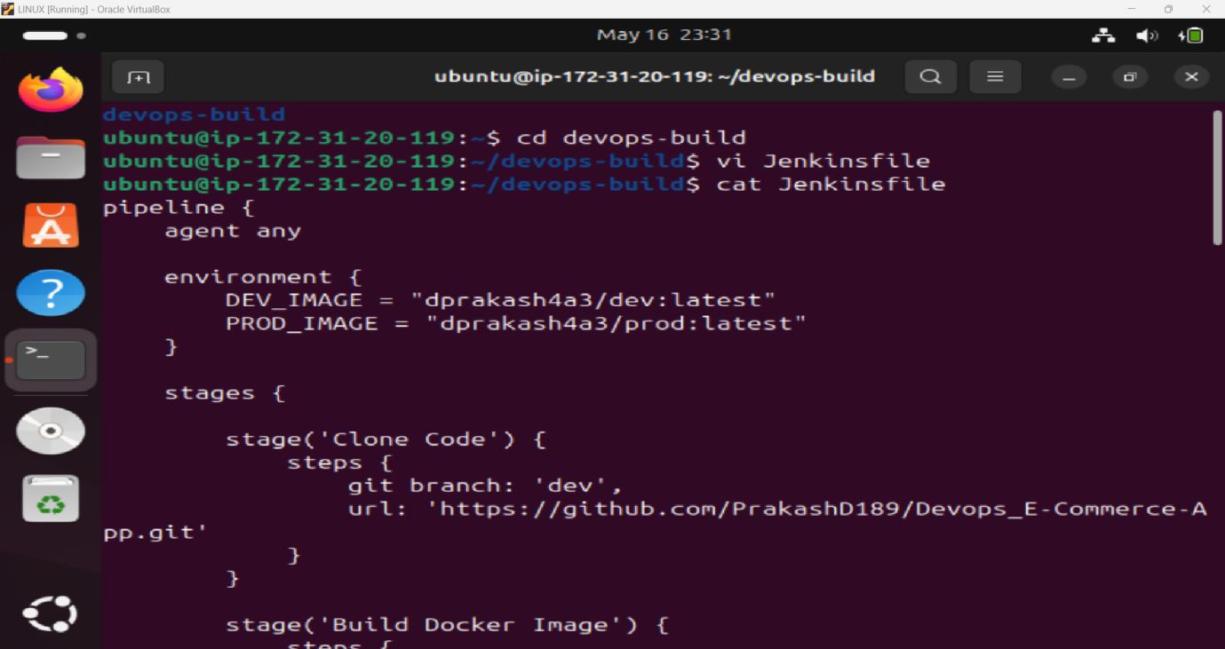

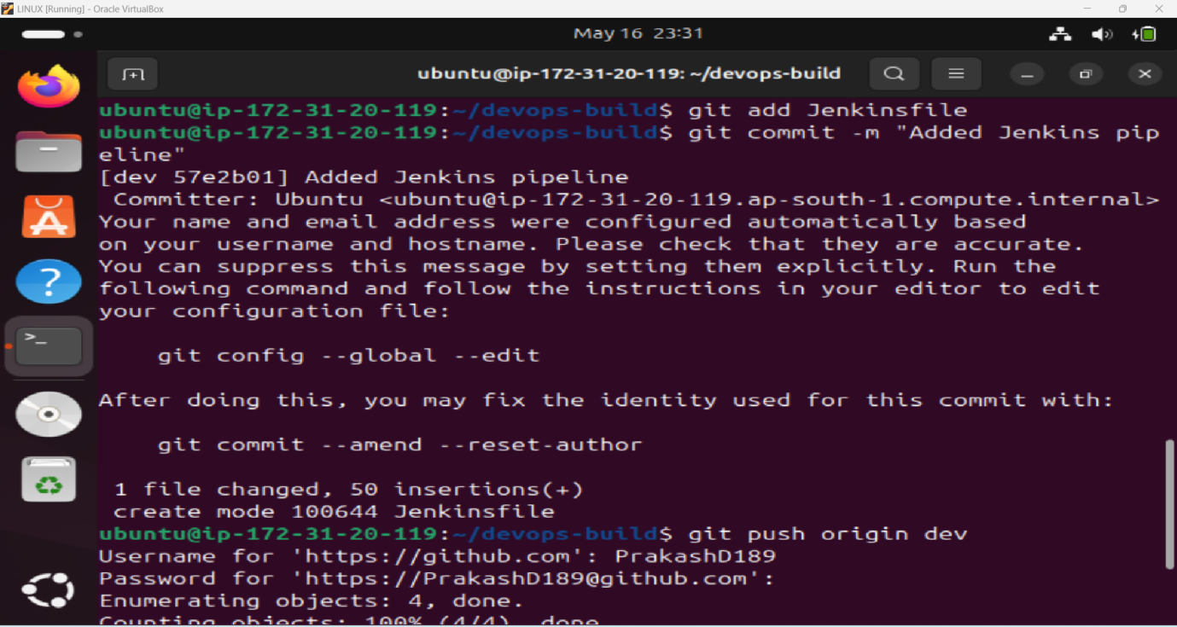

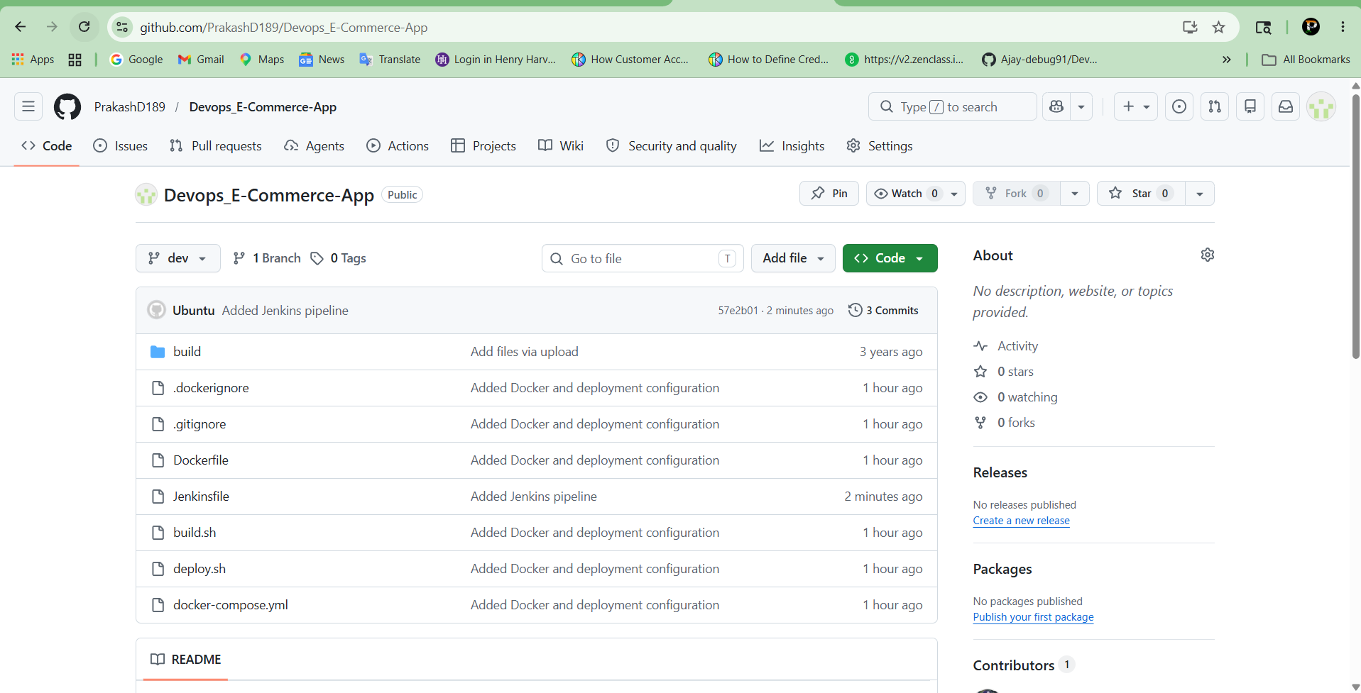

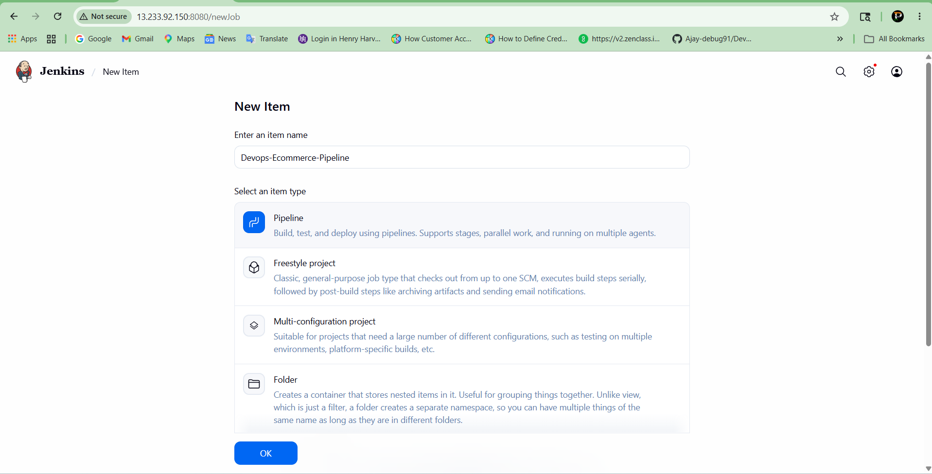

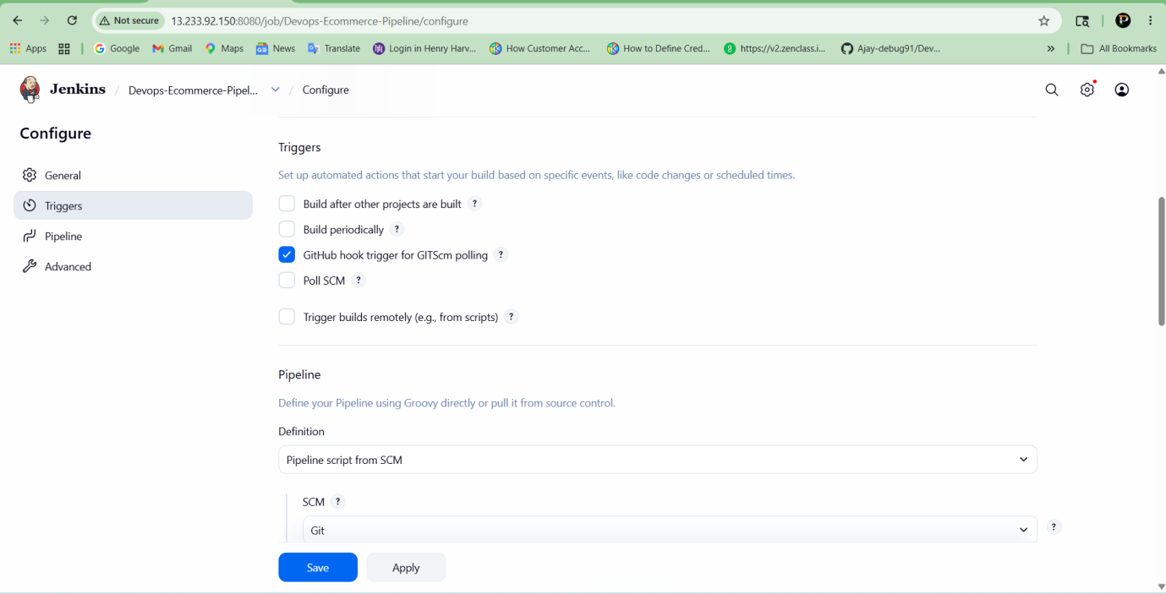

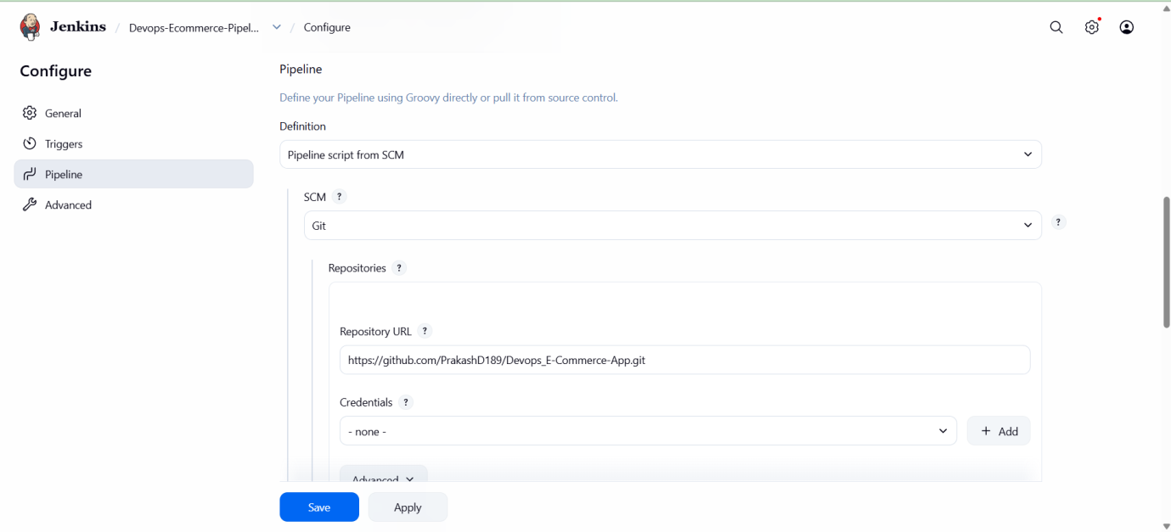

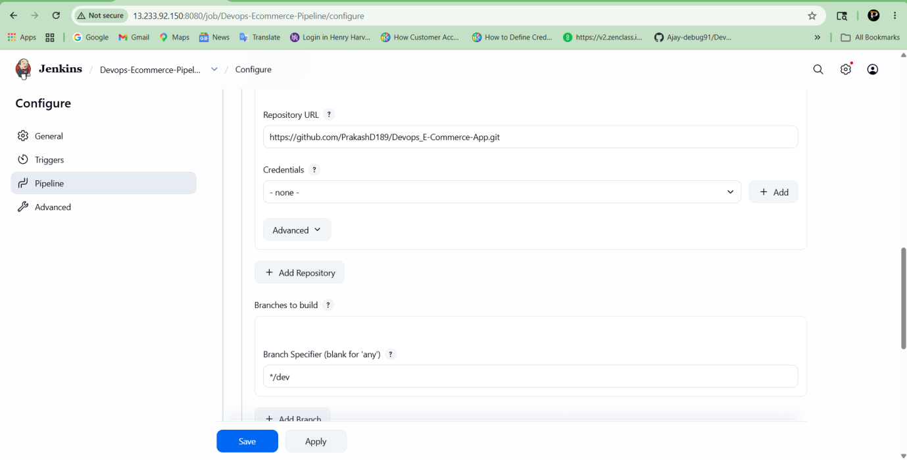

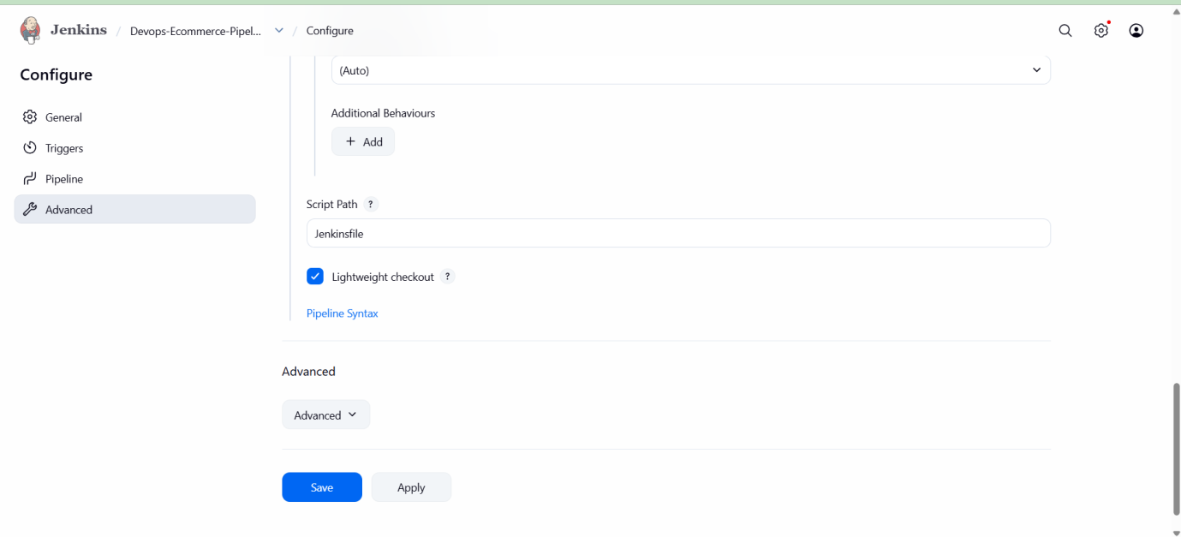

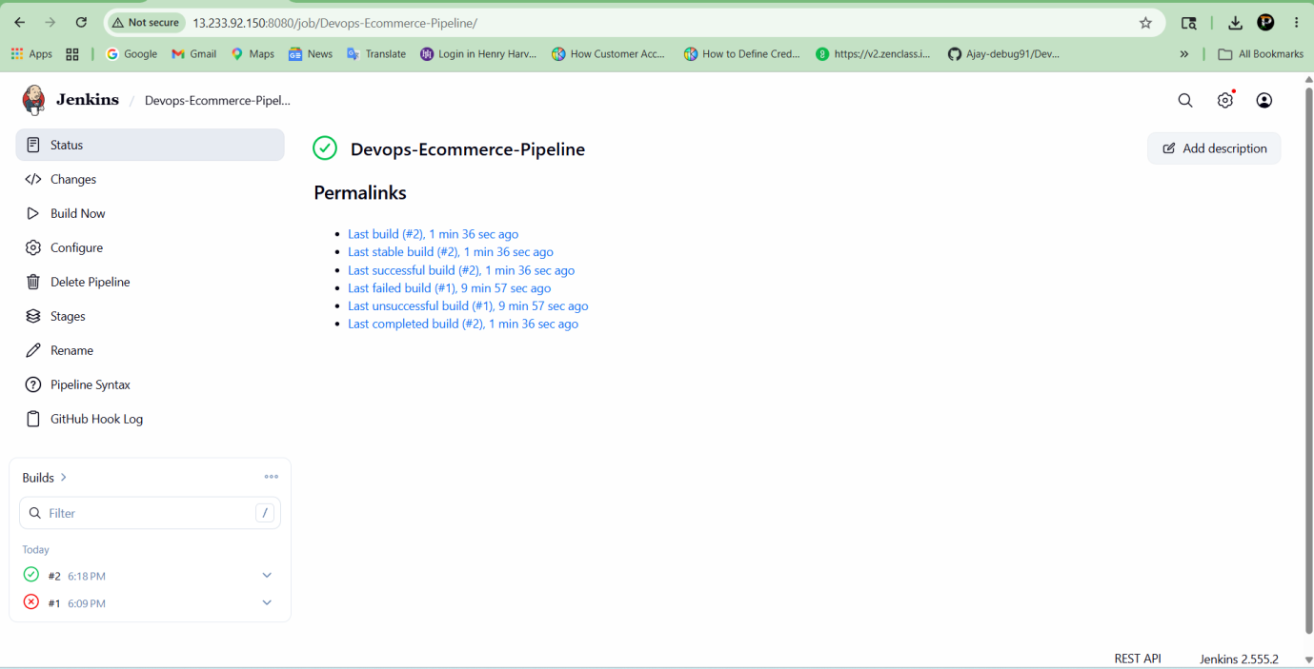

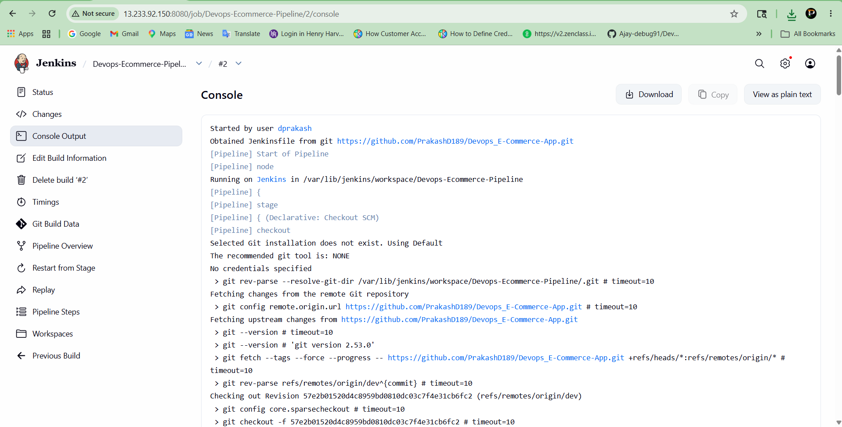

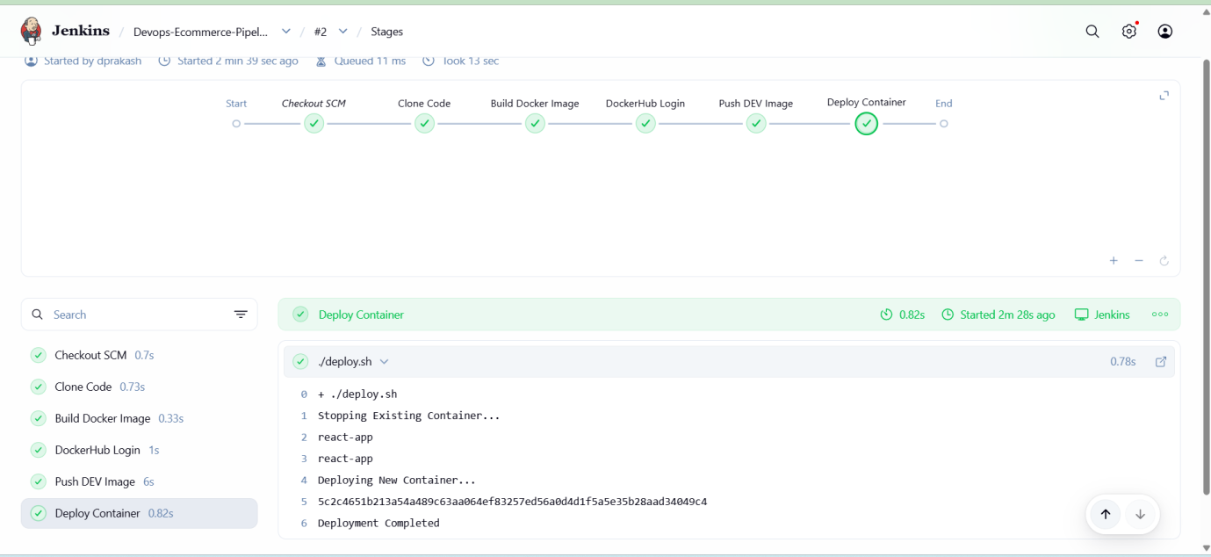

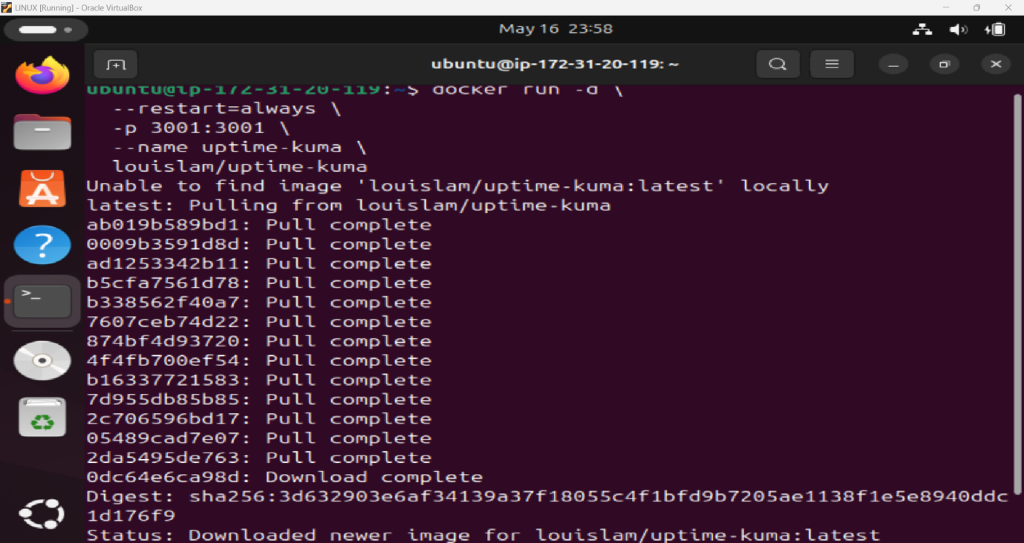

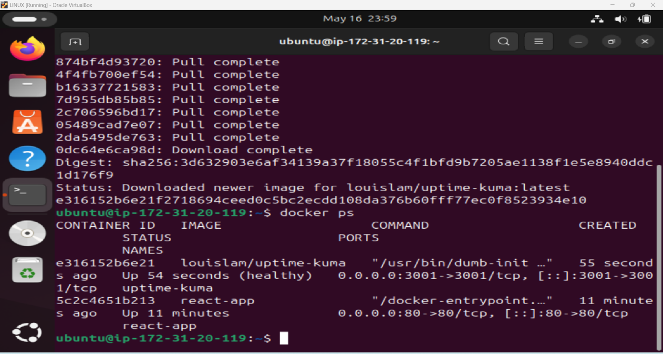

Monitoring:

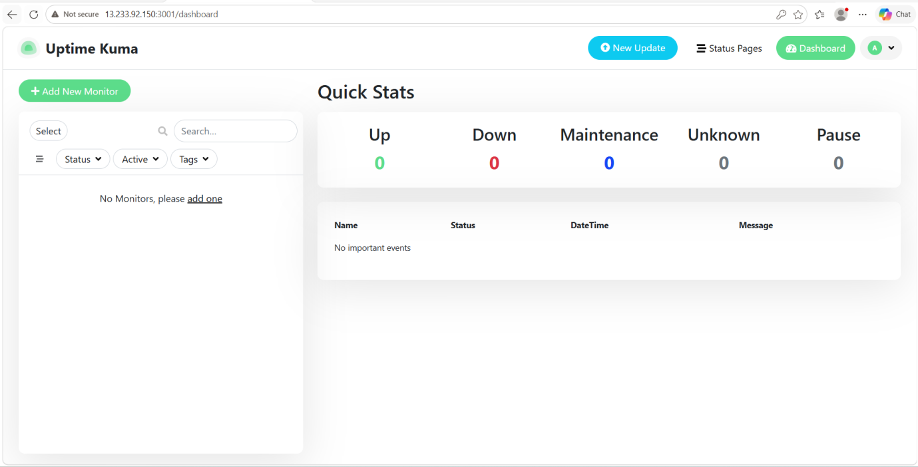

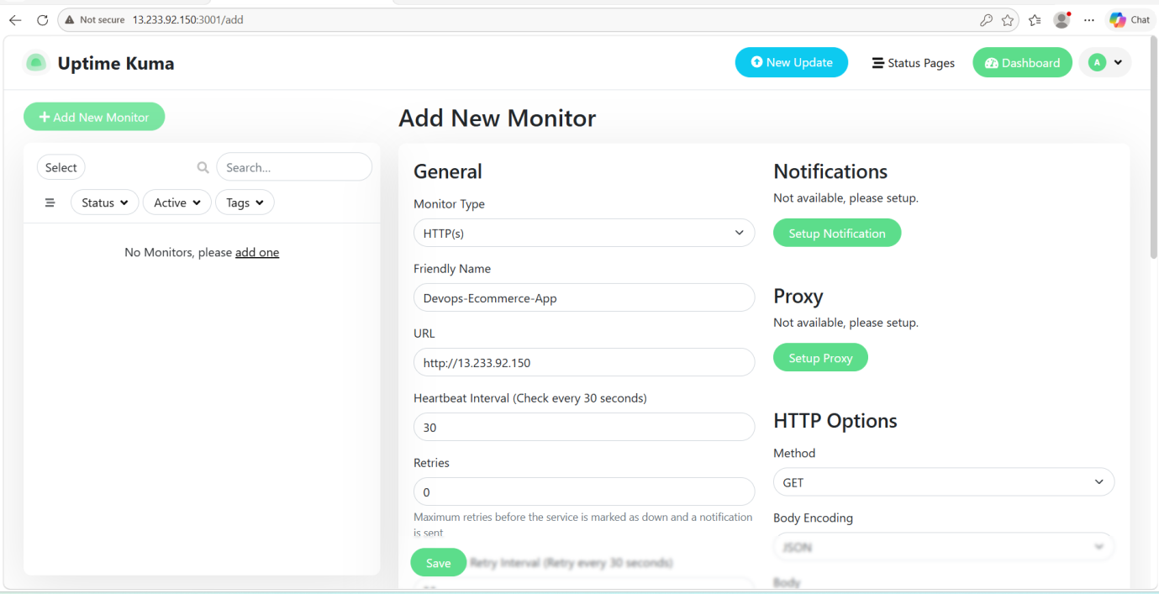

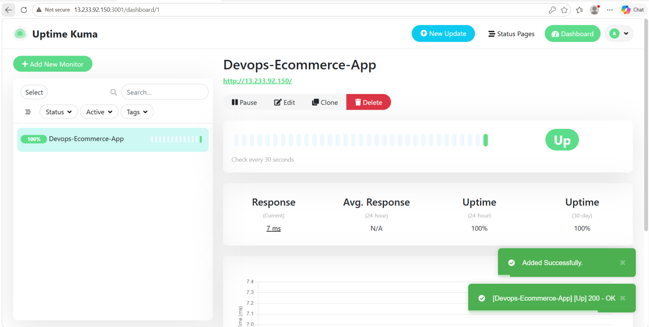

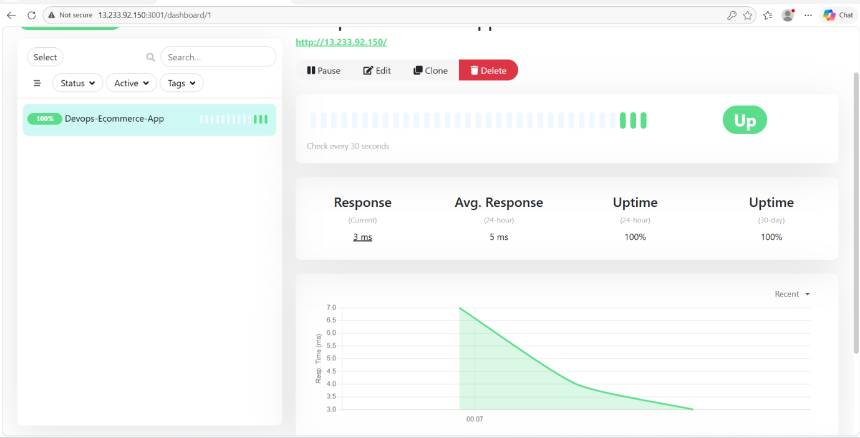

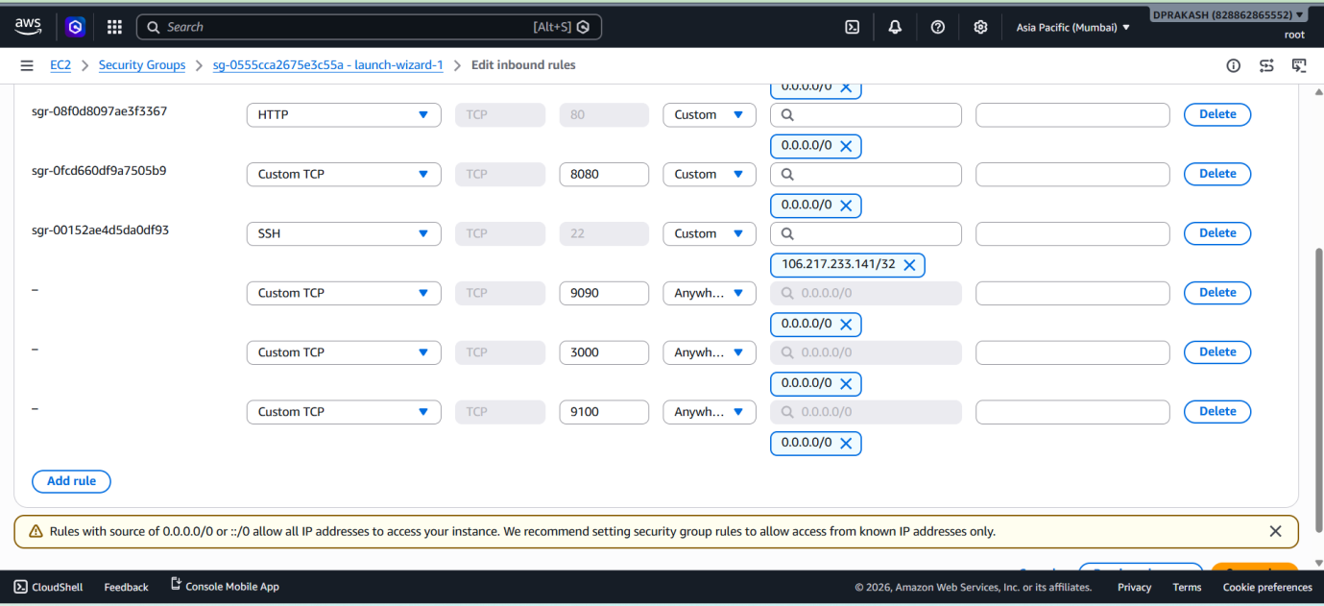

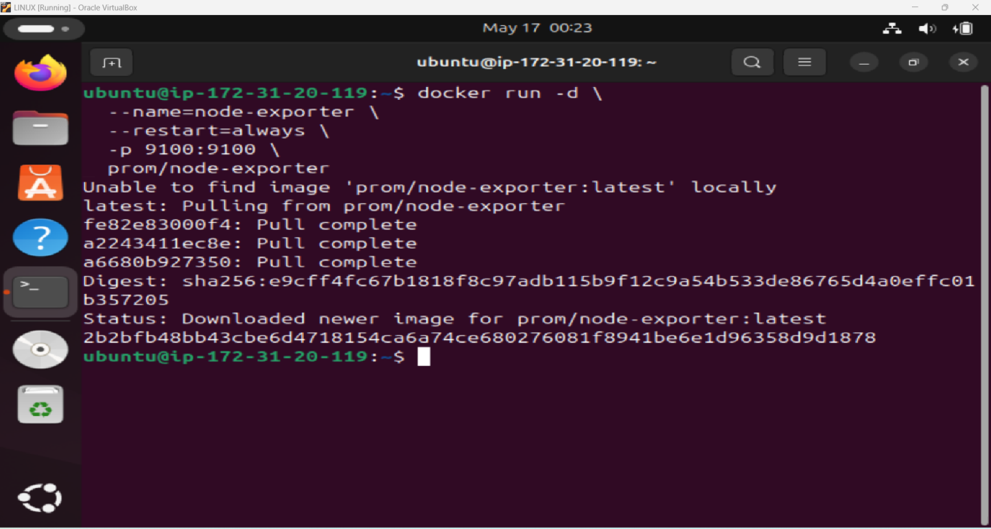

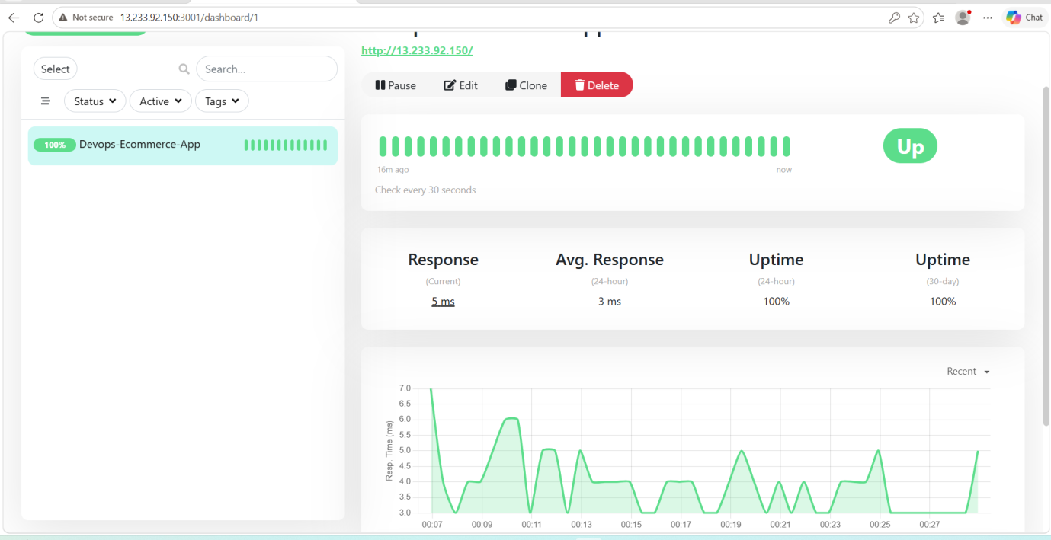

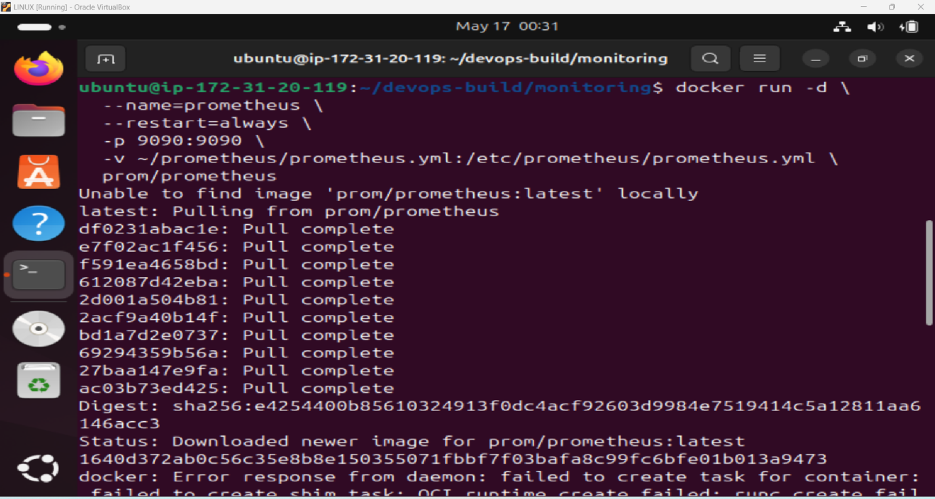

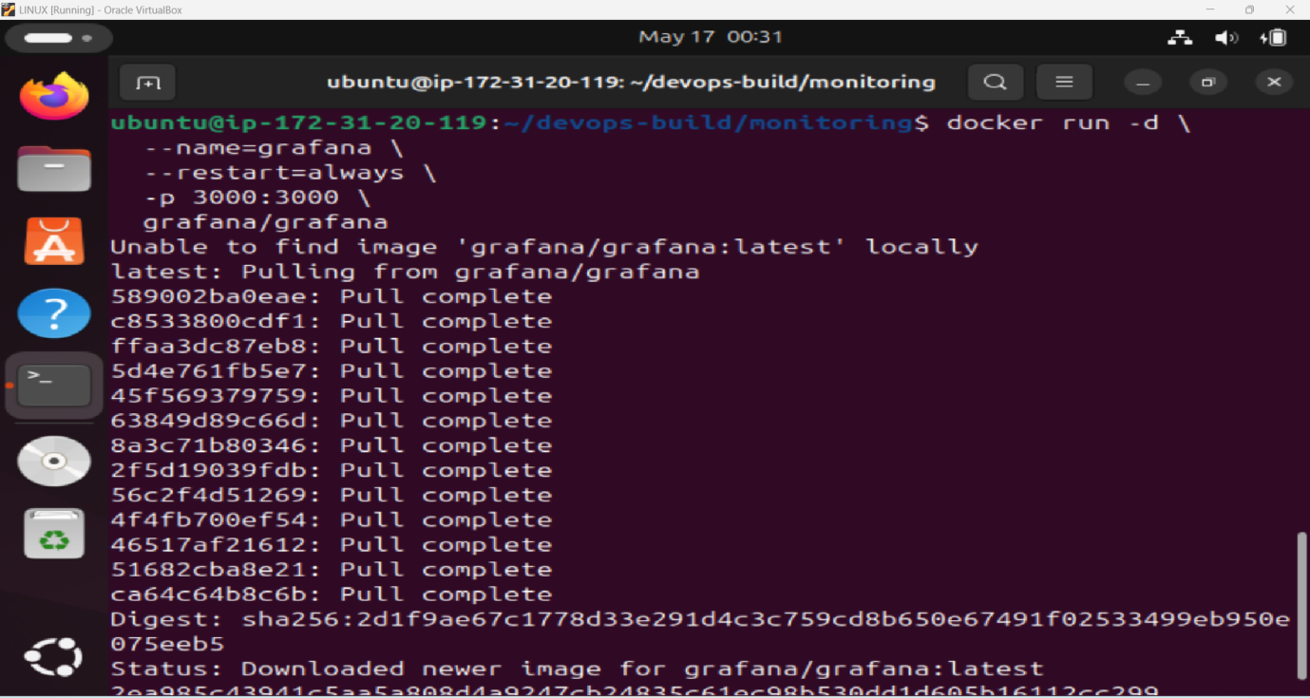

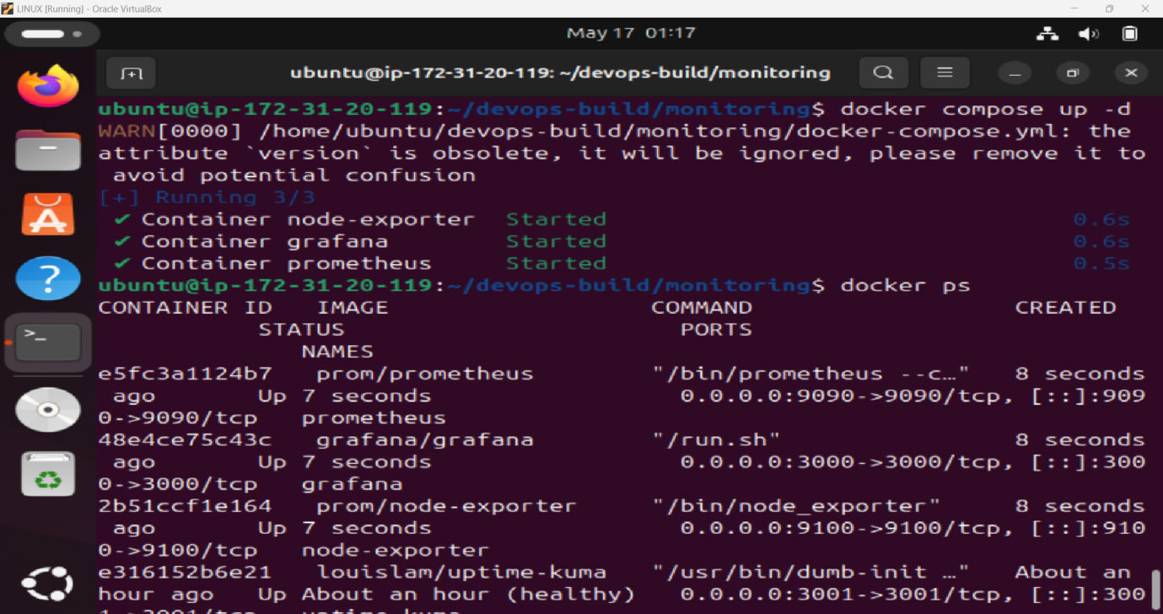

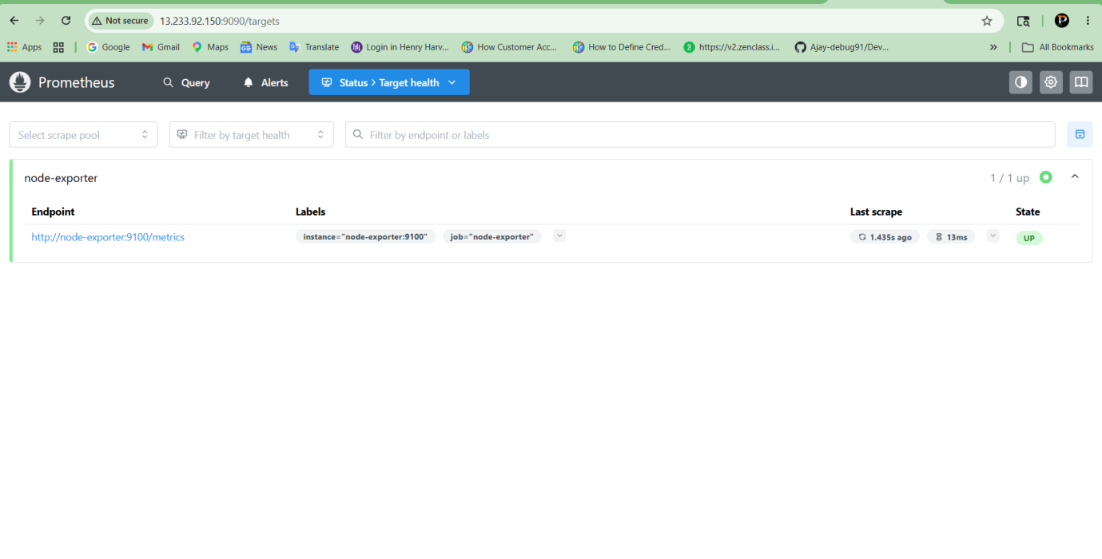

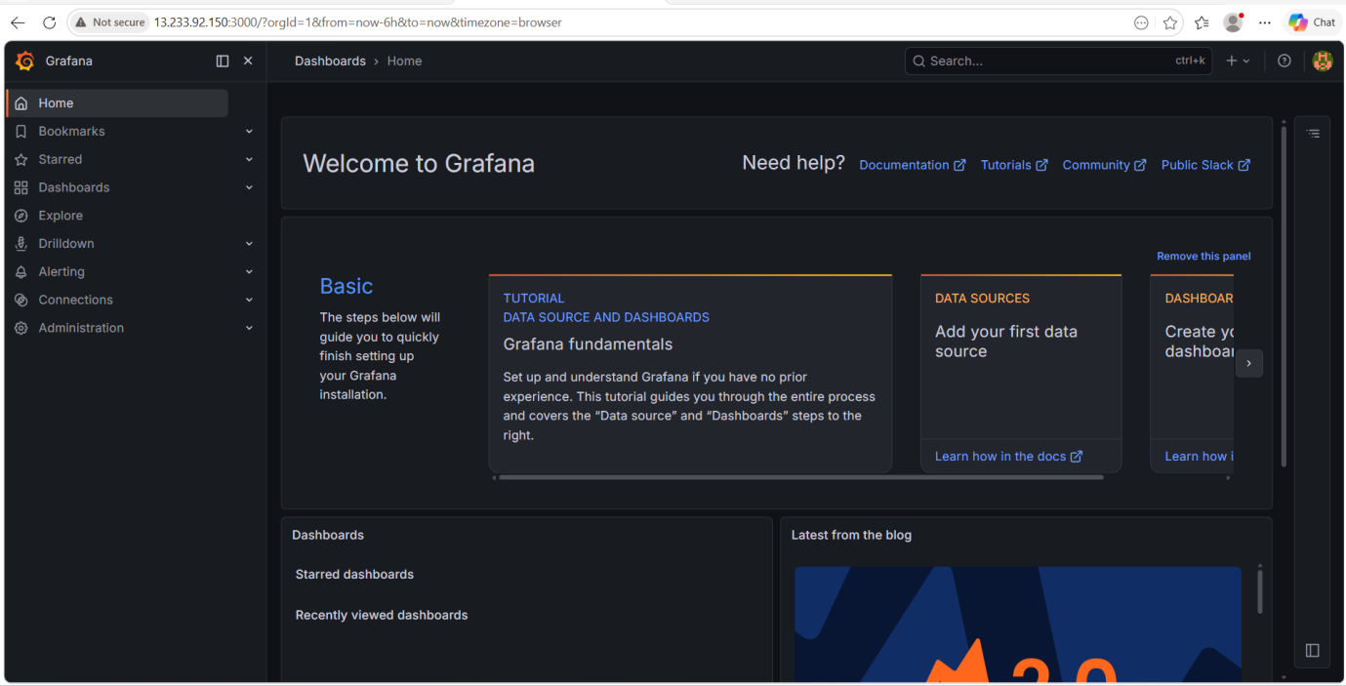

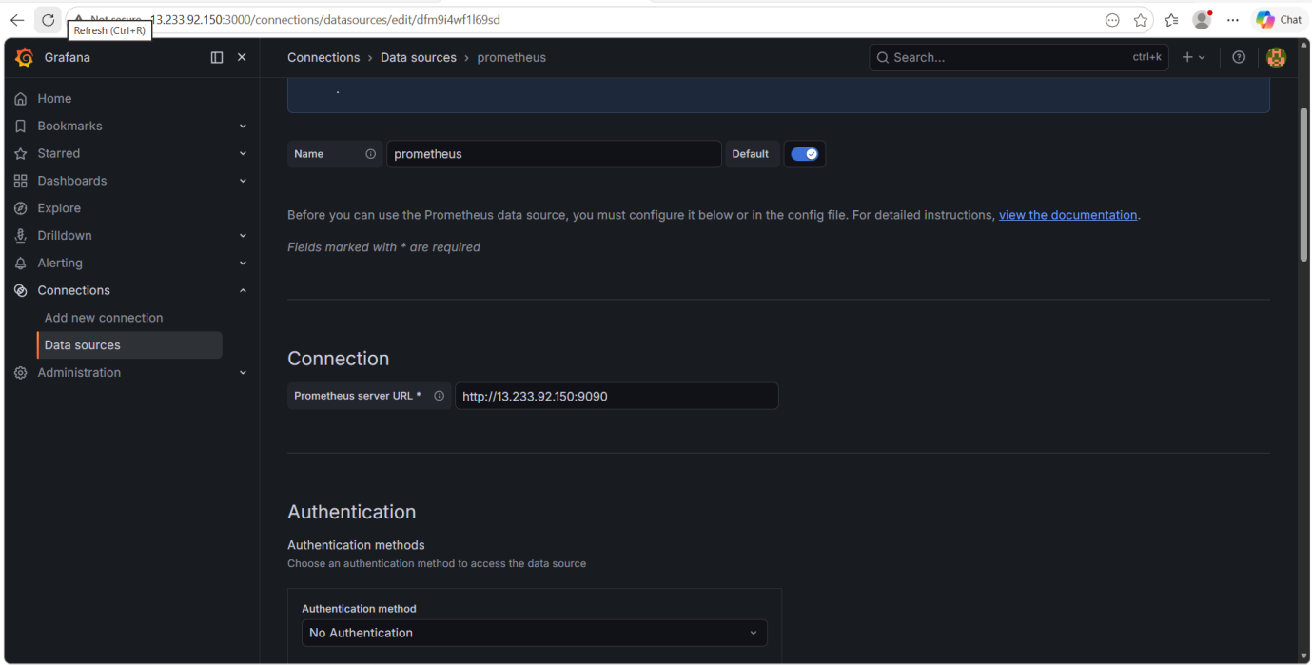

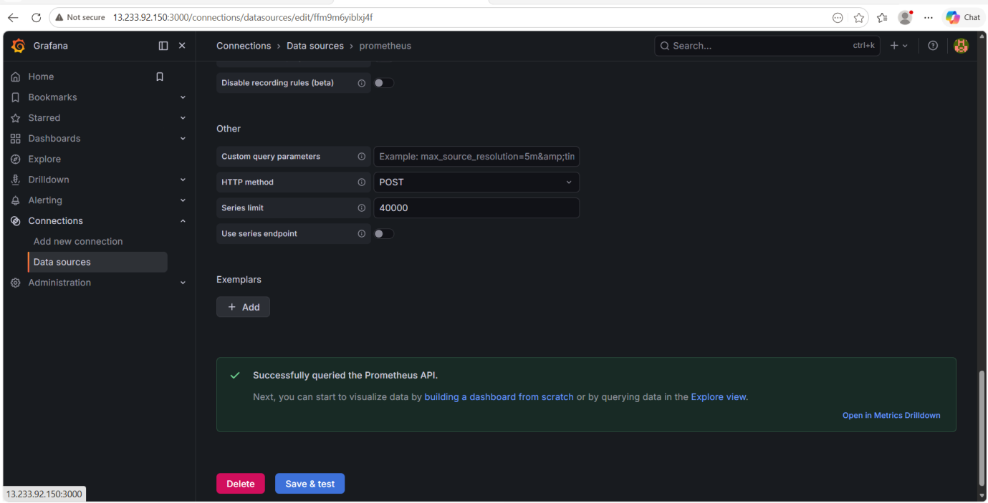

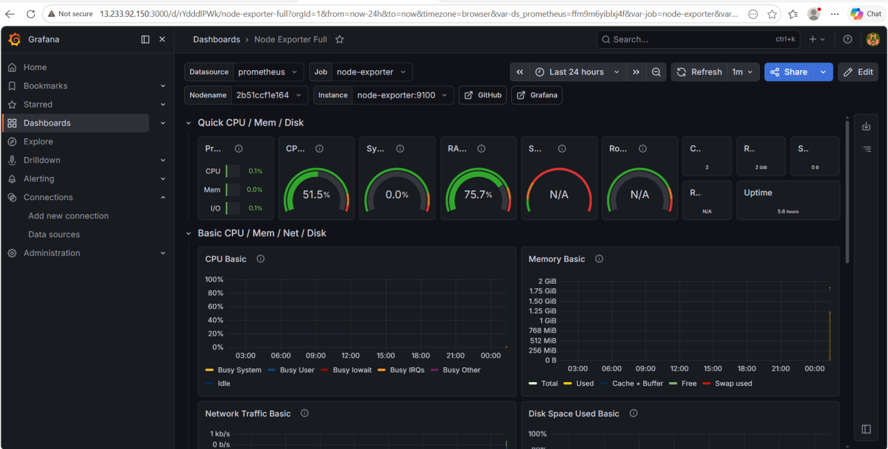

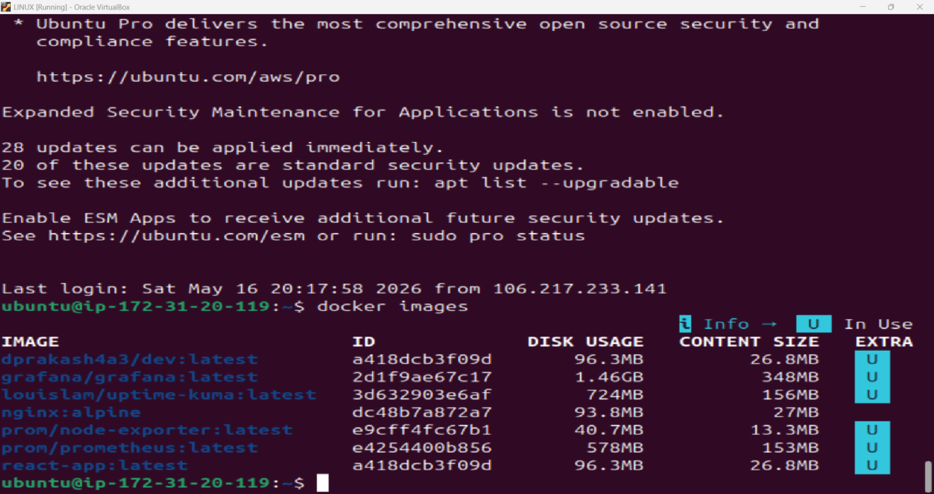

IMAGE | ID | DISK USAGE | CONTENT SIZE | EXTRA
dprakash4a3/dev:latest | a418dcb3f09d | 96.3MB | 26.8MB | U
grafana/grafana:latest | 2d1f9ae67c17 | 1.46GB | 348MB | U
louislam/uptime-kuma:latest | 3d632903e6af | 724MB | 156MB | U
nginx:alpine | dc48b7a872a7 | 93.8MB | 27MB
prom/node-exporter:latest | e9cff4fc67b1 | 40.7MB | 13.3MB | U
prom/prometheus:latest | e4254400b856 | 578MB | 153MB | U
react-app:latest | a418dcb3f09d | 96.3MB | 26.8MB | U

